**IoT (Internet of Things)**

|  |  |  |  |  |
| --- | --- | --- | --- | --- |
| **Sl No** | **Author/Developer** | **Reviewer** | **Approver** | **Date** |
| **1** | **Nagaraju Kotta** | **Syed G Farees** | **Garima** |  |
| **2** |  |  |  |  |

**IoT (Internet of Things)**

**Overview**

Internet of Things service is designed to facilitate and support the implementation of IoT applications.

**Architecture**

Internet of Things service provides interfaces for registering devices and their specific data types, sending data to a database running on the SAP Cloud Platform in a secure and efficient manner, and storing and providing access to the data stored. The respective services are distributed across two main components: Remote Device Management Service (RDMS) and Message Management Service (MMS). Moreover, there is a graphical user interface called Internet of Things service cockpit, which provides access to the various services.

The following figure provides an overview of the architecture.

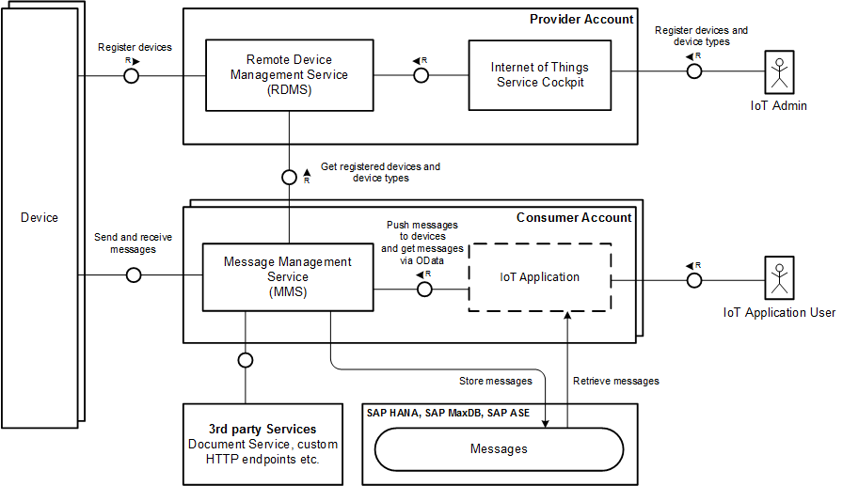

The MMS provides various APIs that can be used by devices to send data to Internet of Things service. It processes the data and persists the data in the databases connected. There may be other use cases, though, which require forwarding the data to a message broker, event stream processor or even a document repository.

The Internet of Things service cockpit is the main interface for users to interact with the Remote Device Management Service (RDMS). You can use it to register new devices, to define the schema of messages (device types and message types) they can send and receive, as well as to establish the trust relationship needed by devices to interact with the Message Management Service (MMS). The Internet of Things service cockpit and RDMS are provided as cloud services and can be used with subscriptions.

**IoT creation steps**

1. Login to the <https://account.hanatrial.ondemand.com/> and provide your trail account username and password

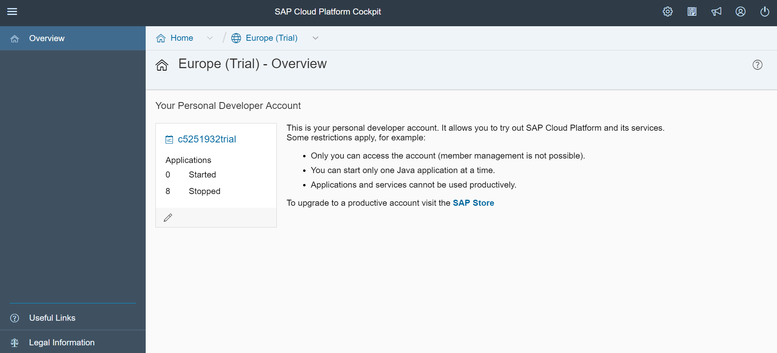

1. Click on your account trail name

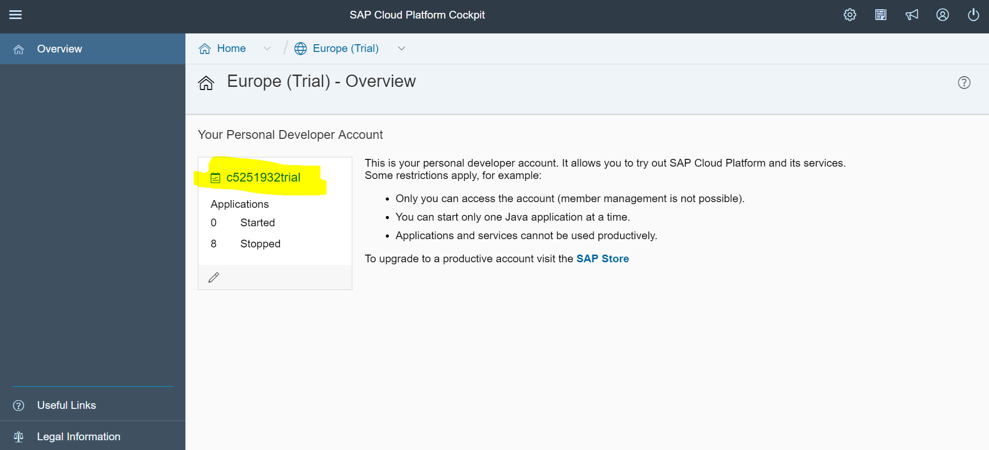

1. Click on “Services” tab and click on “Internet of Things” and enable the service, if not already enabled.

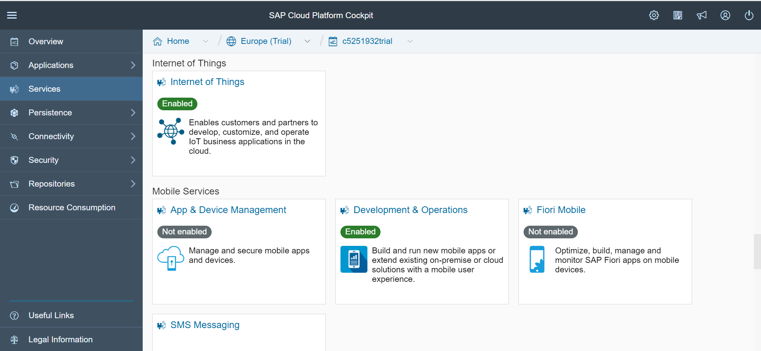

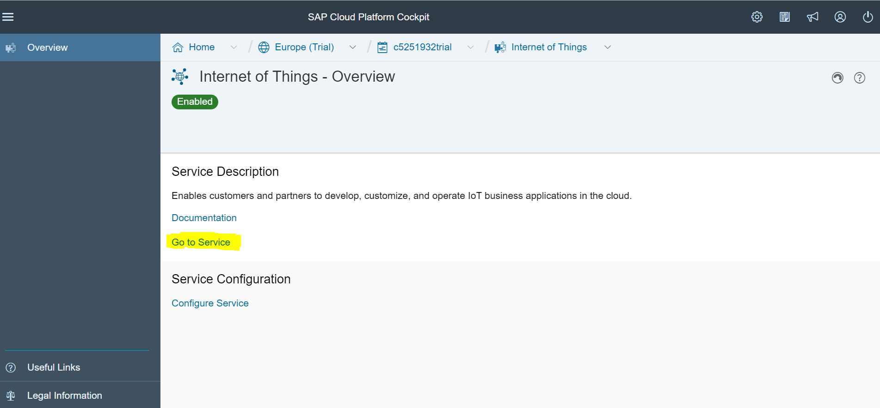

1. Click on “Go to Service” link, it will open in new window

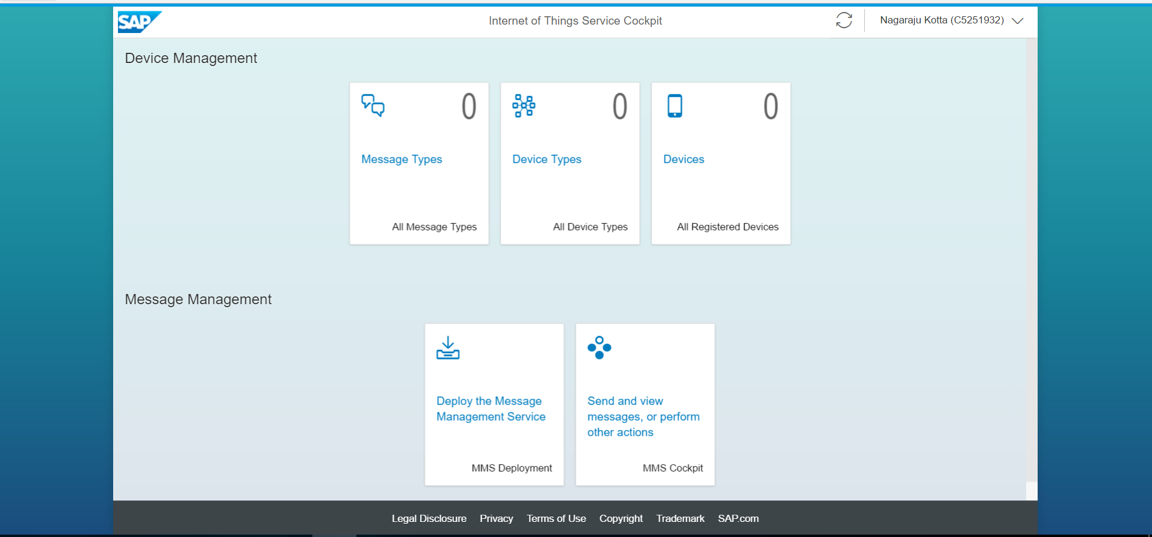

1. Deploy the Message Management Service.
2. Click on “Deploy the Message Management Service” , it will open the page, provide a password of your trail account and click on “Deploy” button.

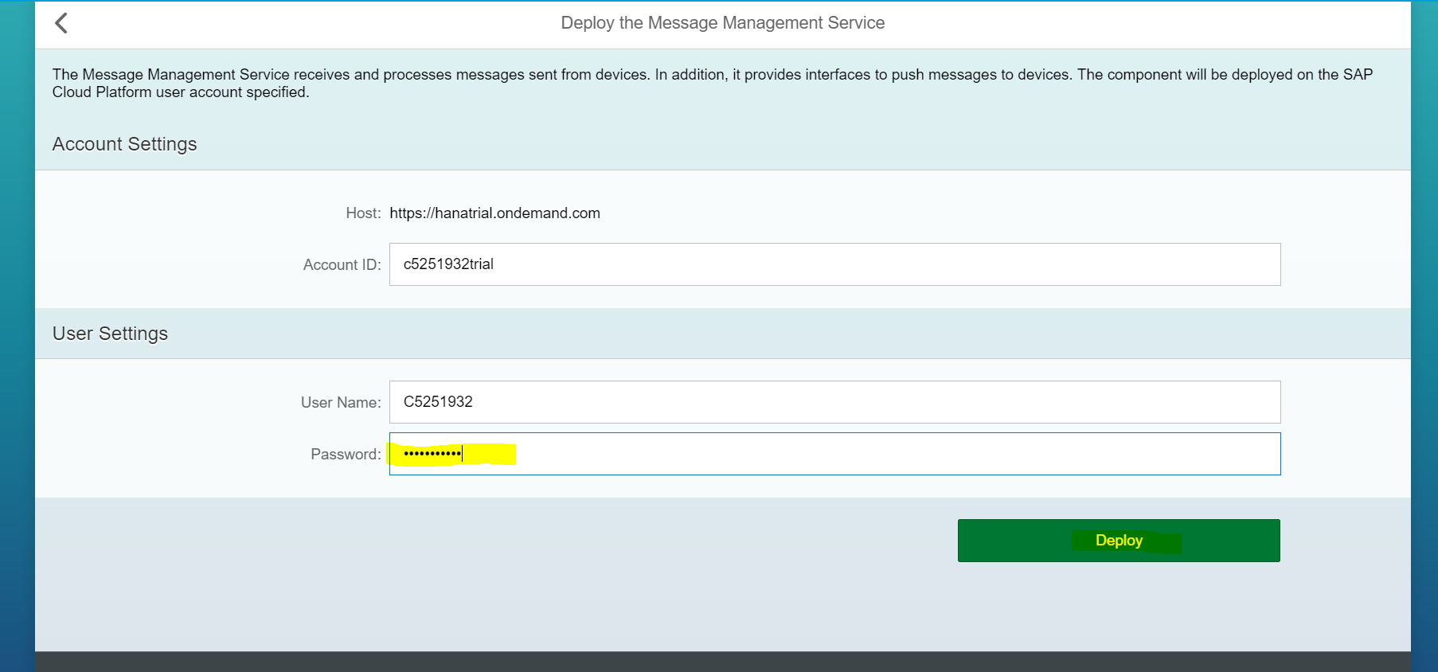

After clicking “Deploy” button it will show popup message, and click on “Deploy” button on popup window.

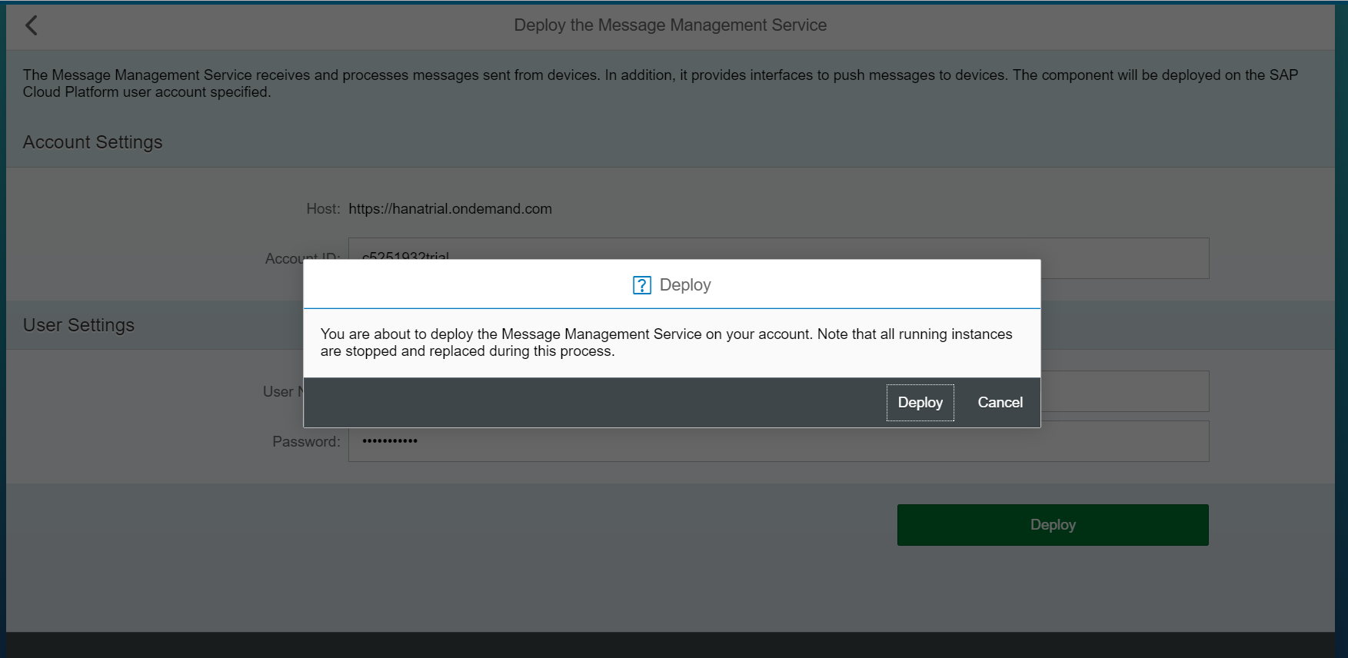

1. Click on the URL highlighted in the below screenshot

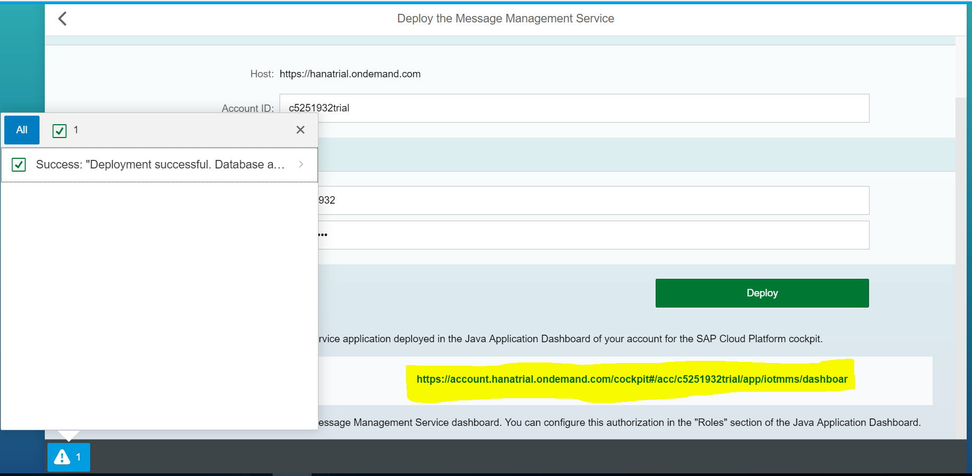

1. After click on url, it would open in a new window

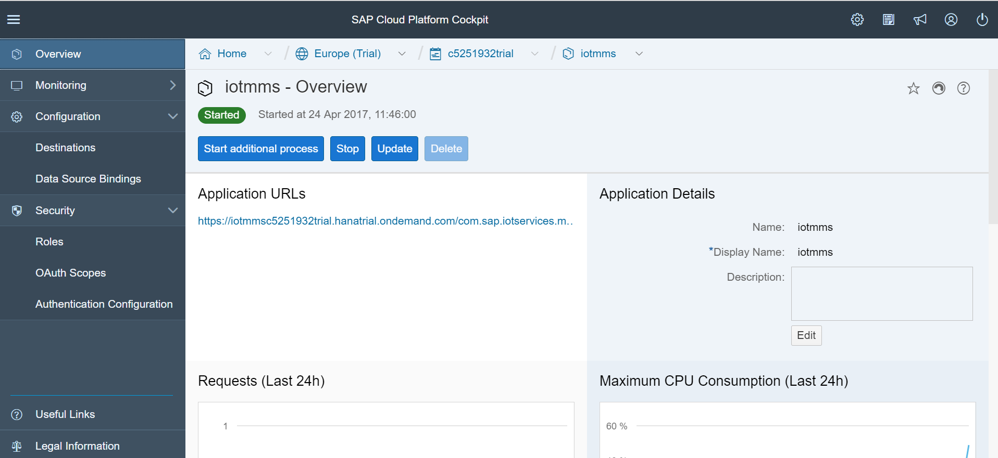

1. Click on “Roles” under “Security” to configure role

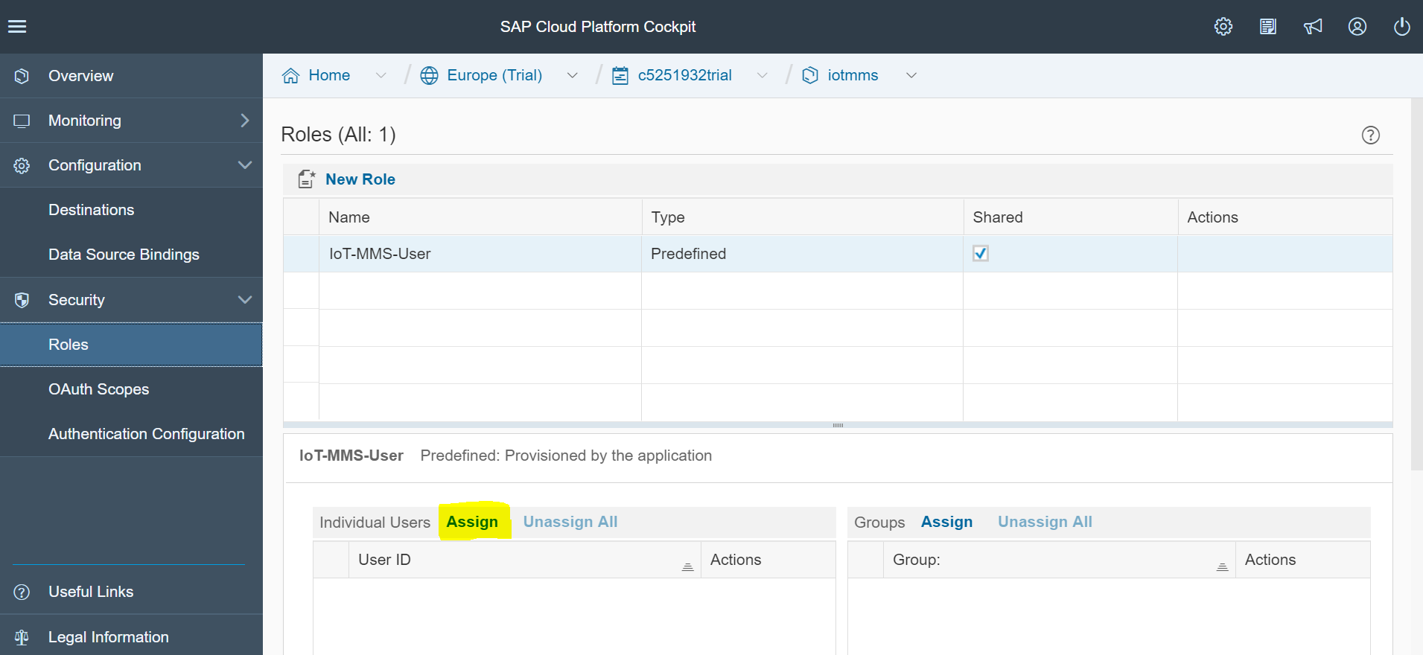

1. Click on “Assign”, enter user id in popup window and click on “Assign” button.

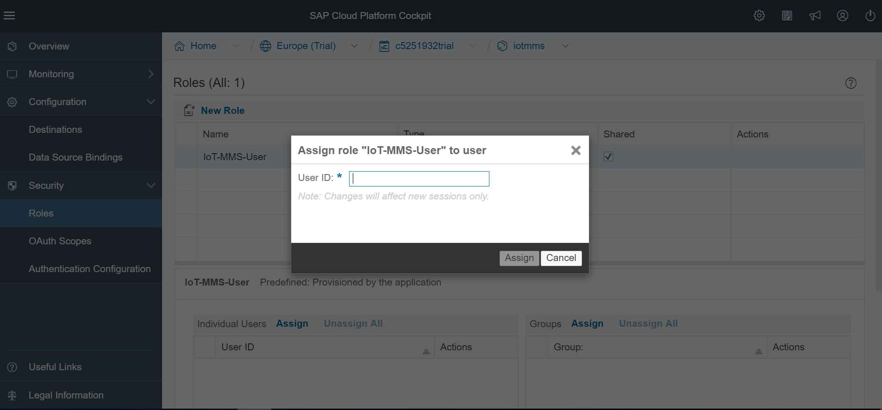

1. Configure “Authentication”. Click on “Authentication Configuration” under “Security” tab

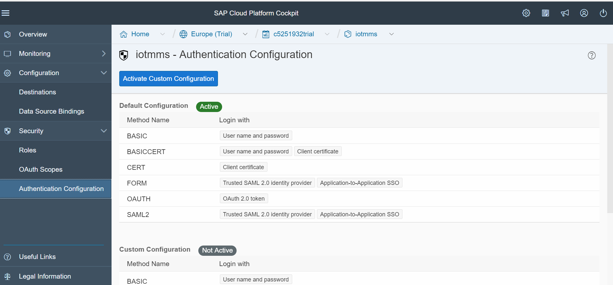

1. Click on “Activate Custom Configuration” click on “FORM”, check the “User name and password” option and click on “Save” button.

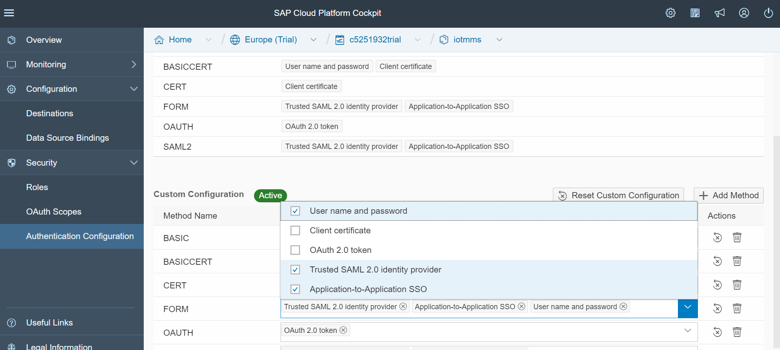

Note :- check only “User name and password” option and deselect the default authentication, otherwise it would lead ‘un authorization’ exception at the time of running “Messaging through HTTP” under “Data Services” of “MMS Cockpit” page.

1. Stop the application and restart again, then the above changes will be reflected.

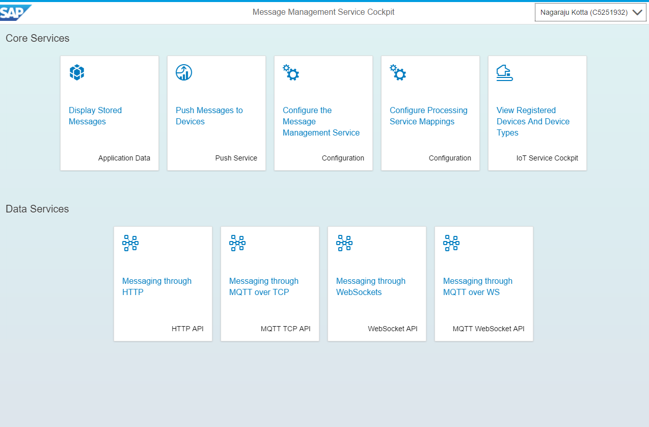

1. Click on ‘+ Add Mapping’ button in ‘Process Service Mappings’ page

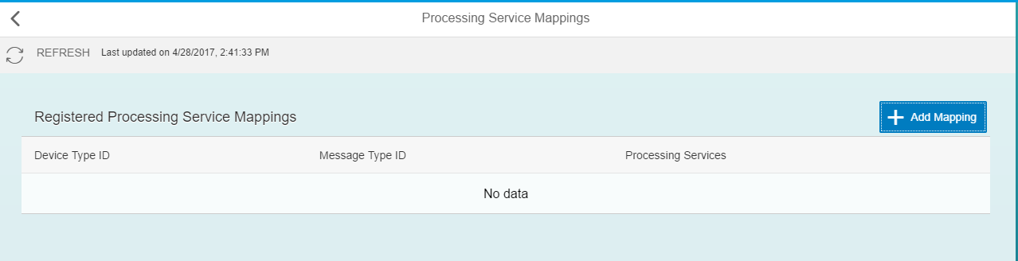

1. Now go back to the IoT cockpit page

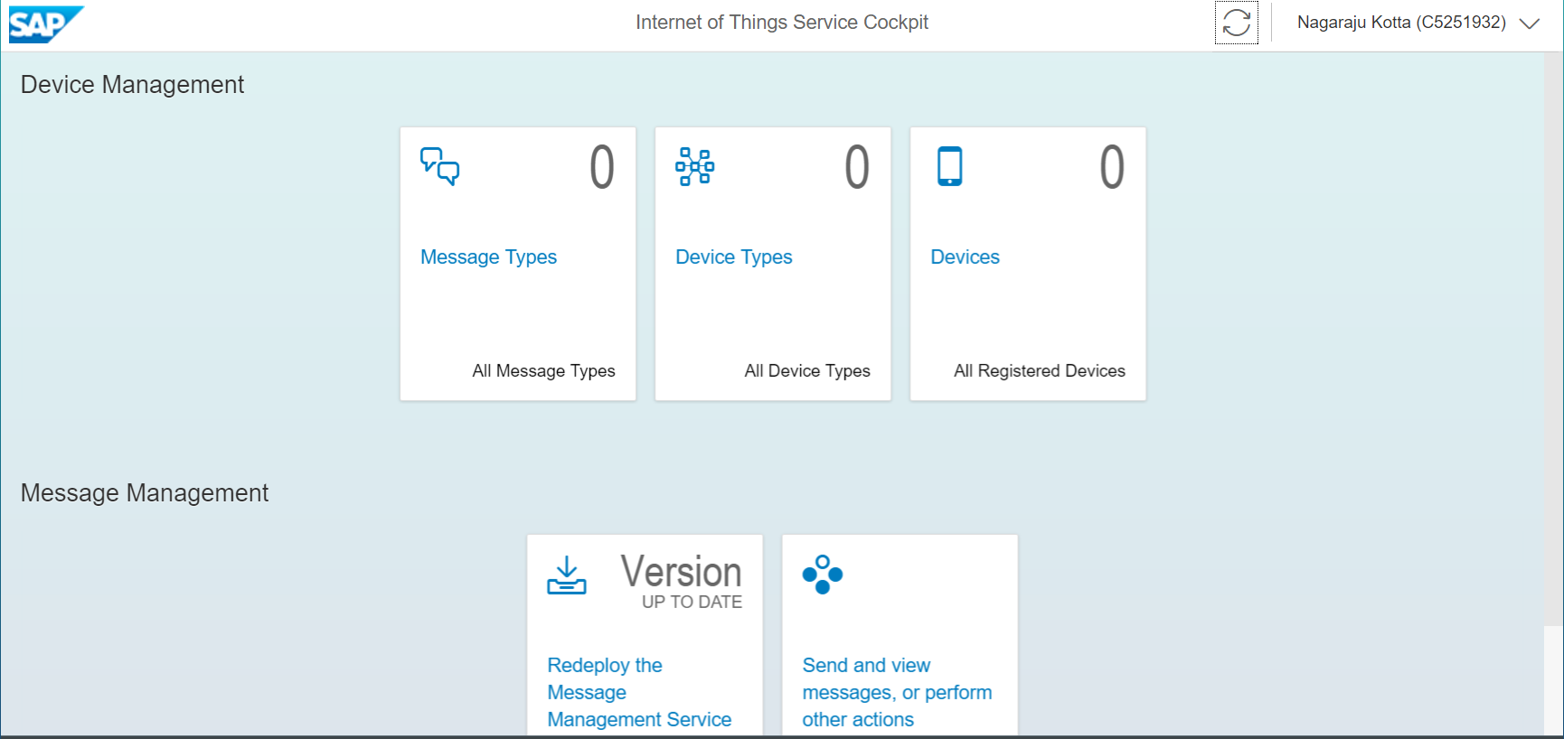

1. Click on “Message Types” , add fields, click on “Create” button.

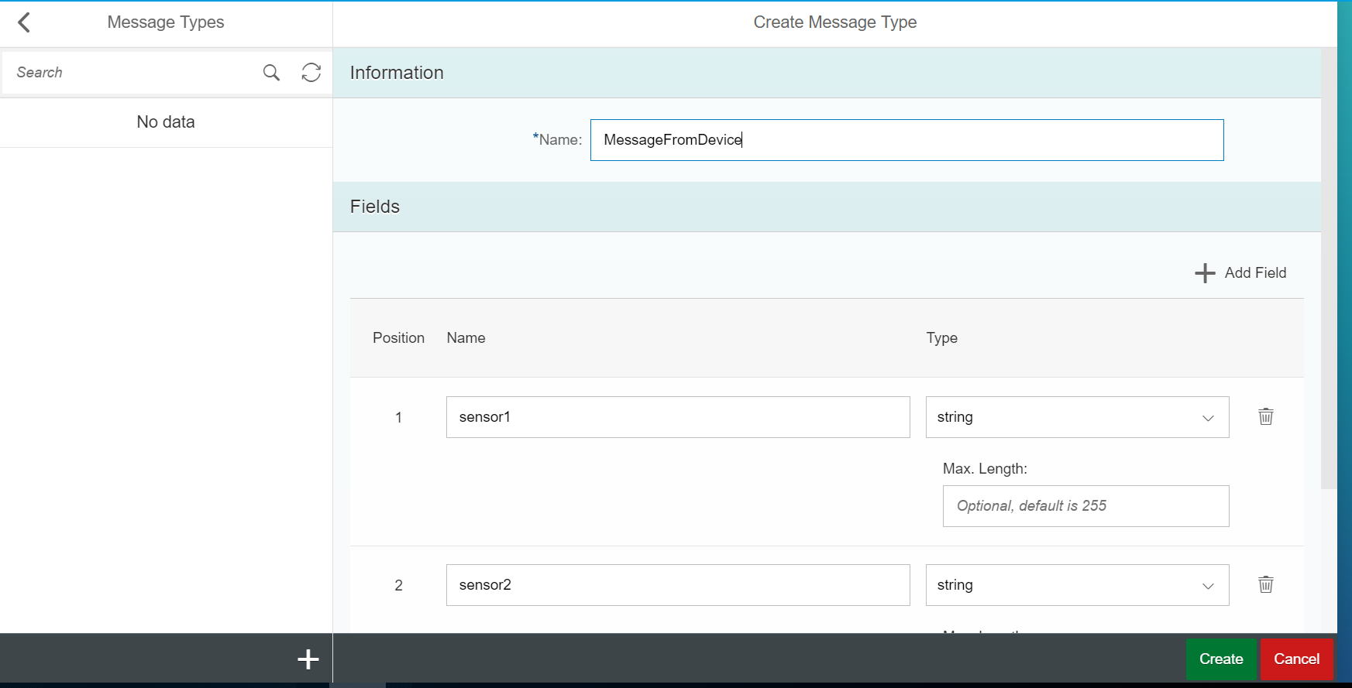

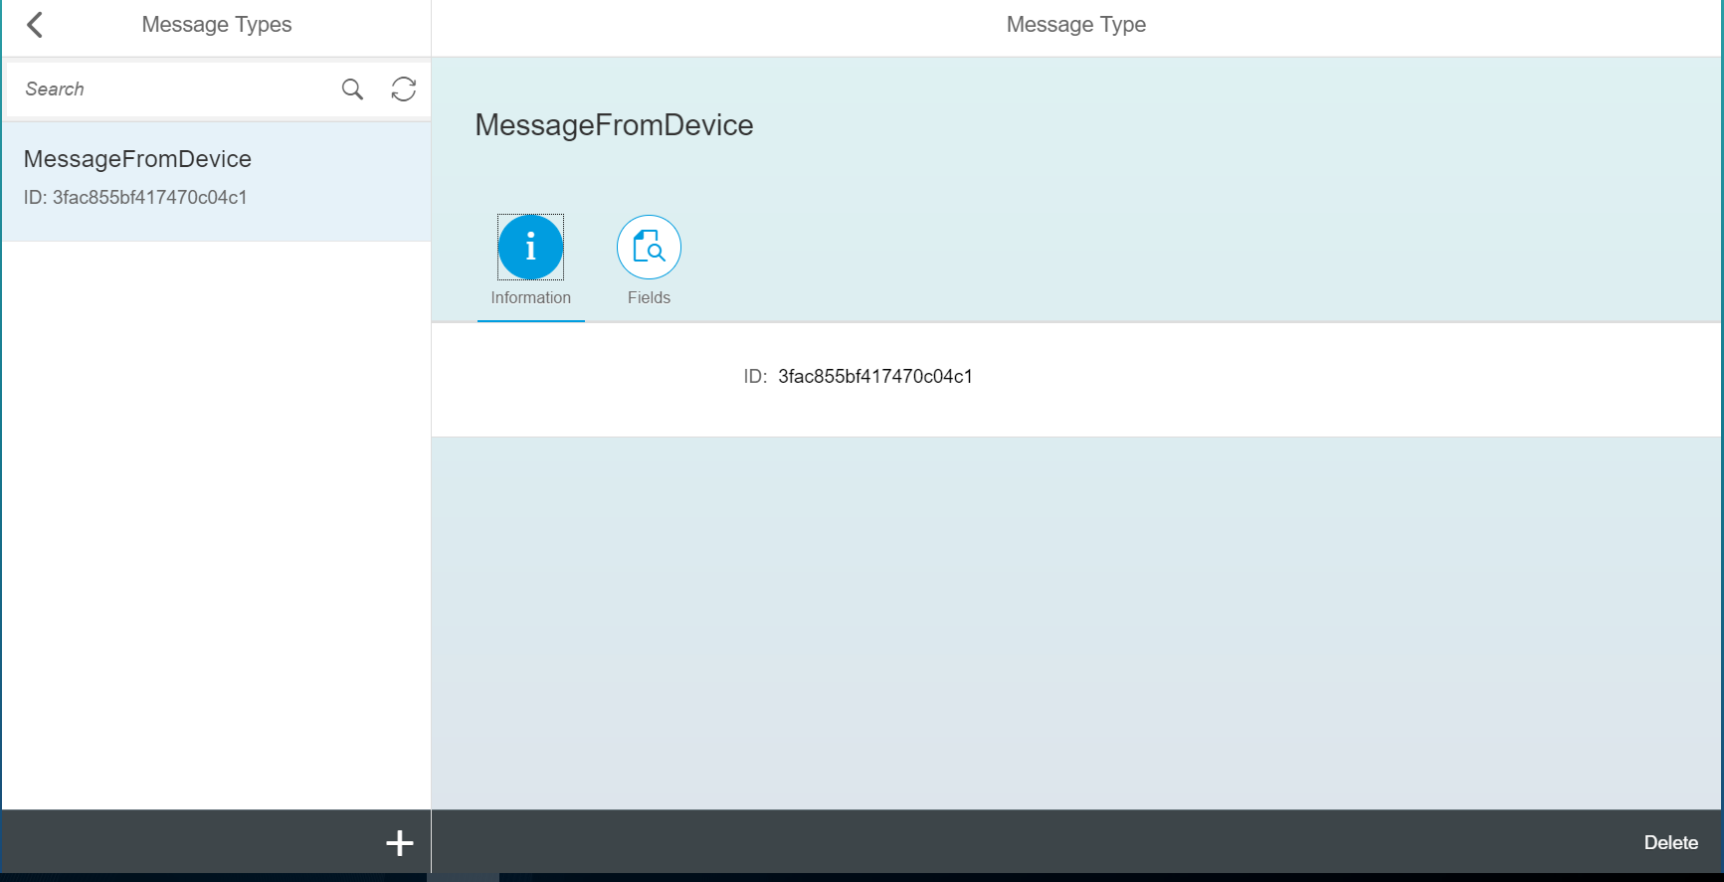

1. Click on “+” button to create additional message types

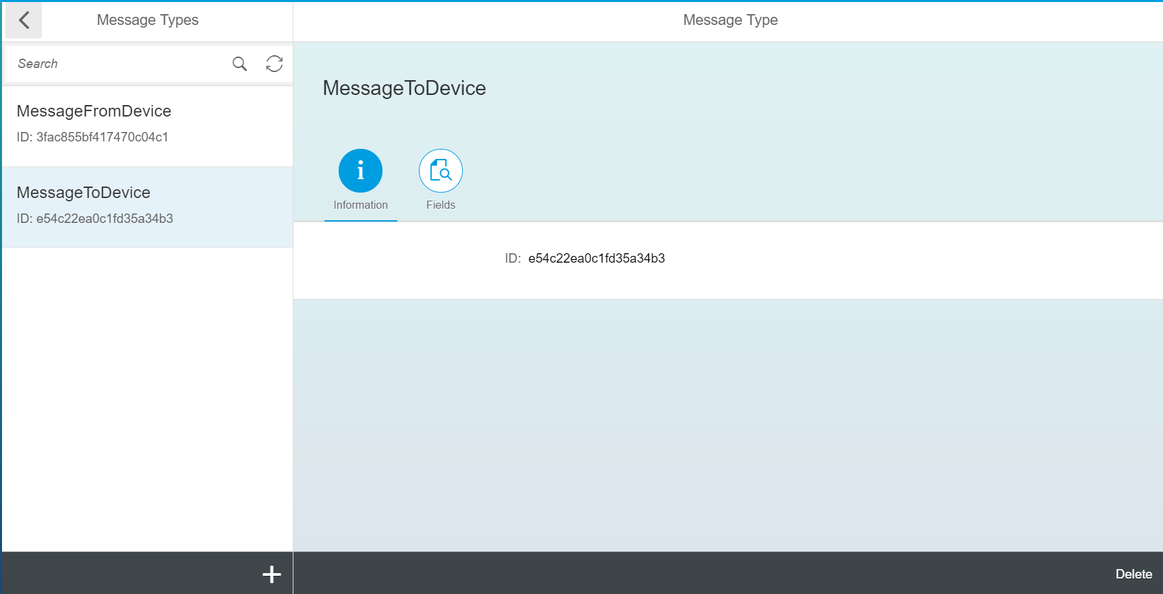

1. Now click on “Device Types” and enter the Name field.

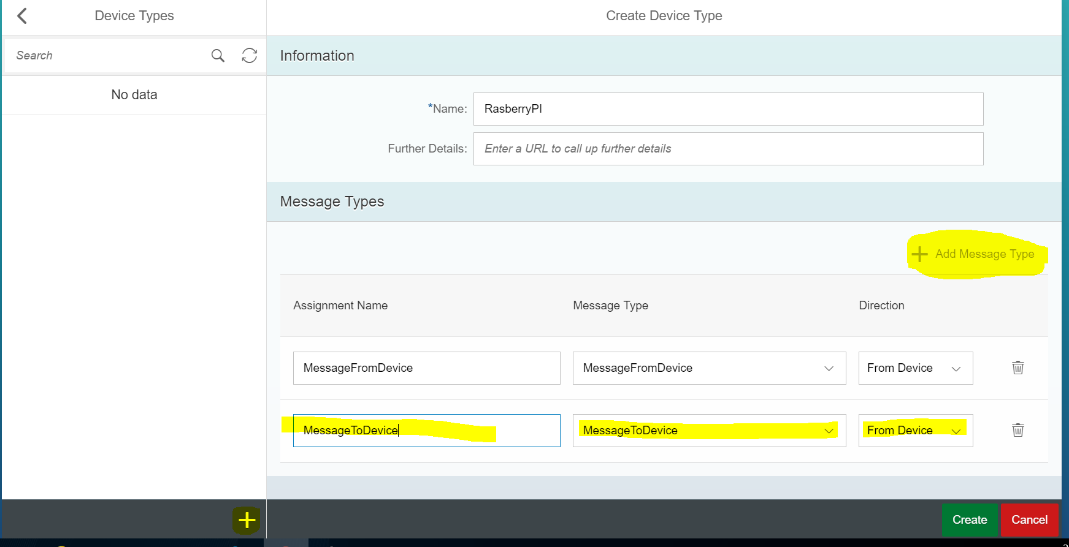

1. Click on “+ Add Message Type” , the default message types should be loaded automatically
2. Choose the Message Type from dropdown options and click on “Create” button.

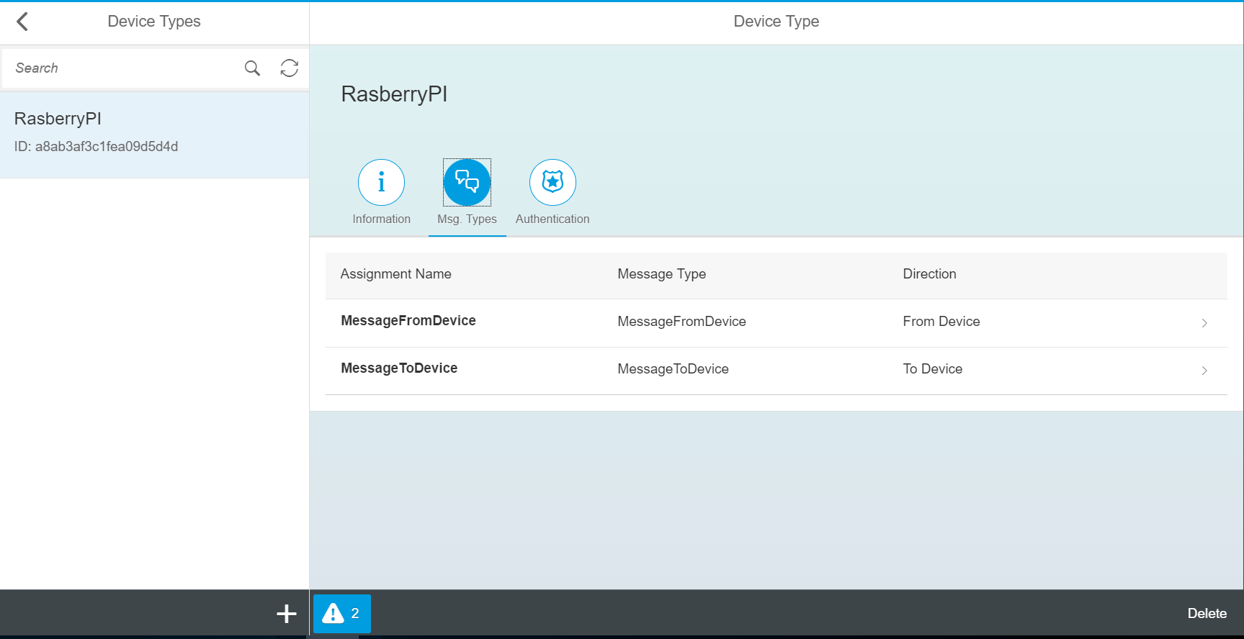

1. If you want add a new device type click on “+” from left button corner, and add new device type. After follow the above (steps 10 and 11).
2. Now go back to the IoT Service Cockpit and select “Devices”

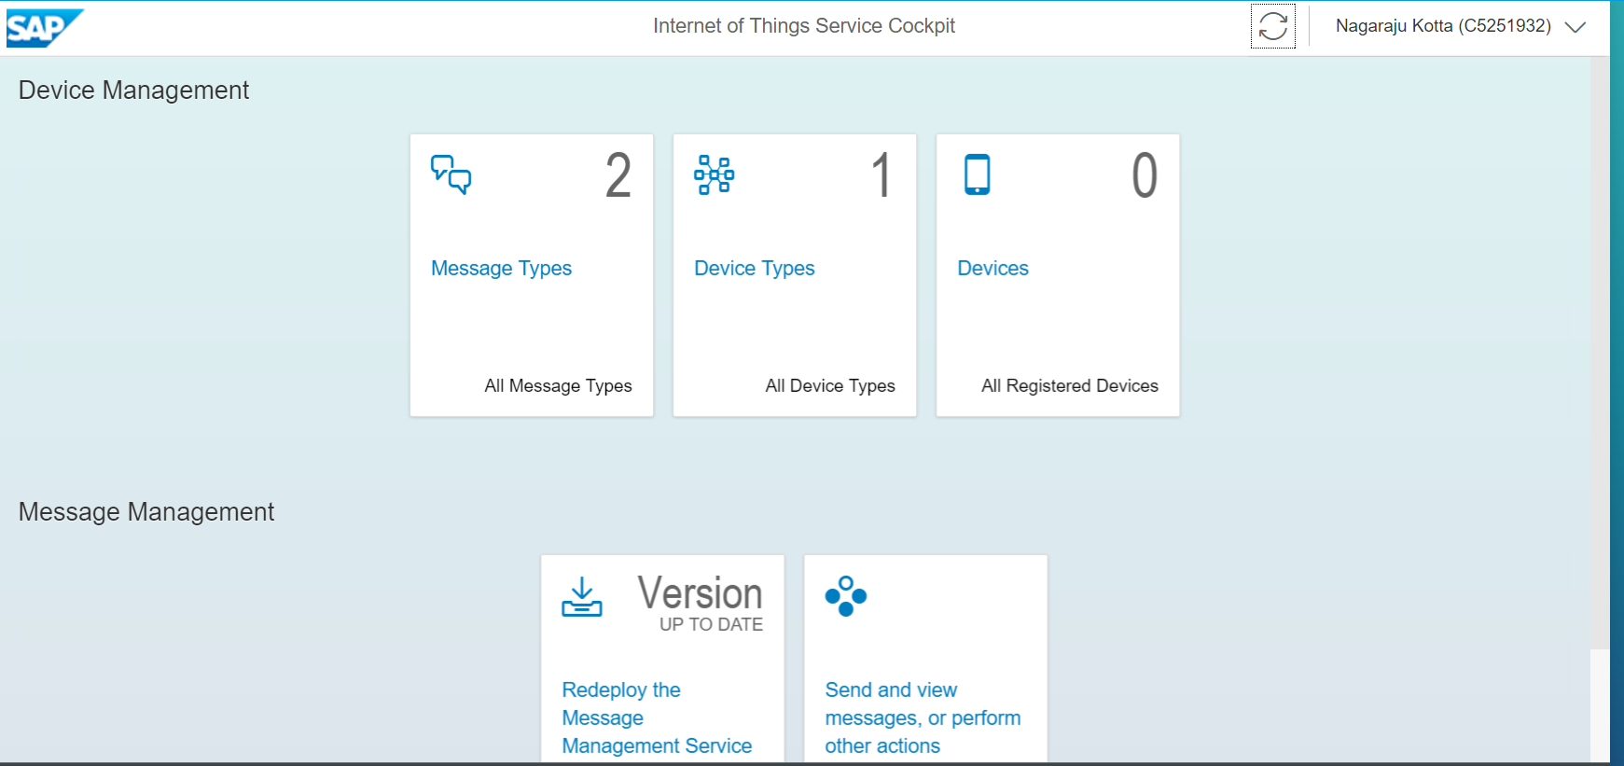

1. Click on “+” button from the bottom left corner.

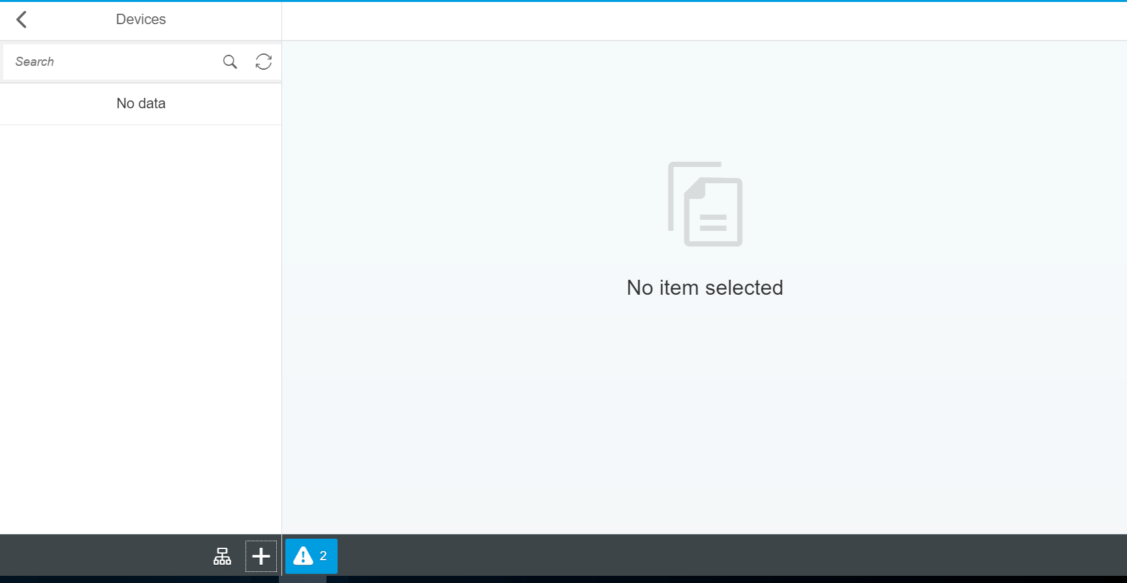

1. Enter the mandatory information and click on “Create” button.

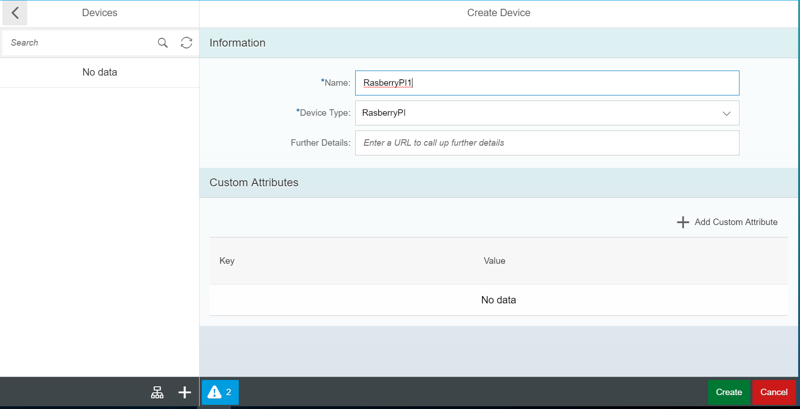

1. Save the OAuth Access Token for later usage (New OAuth access token for device "RasberryPI1" created. Token: 3283ebf6bcd8121f909d4914dd15a8c2)
2. Repeat the above three steps for creating new device.
3. New OAuth access token for device "RasberryPI2" created. Token: d0e25419358e7d487ecaf48bab039a1

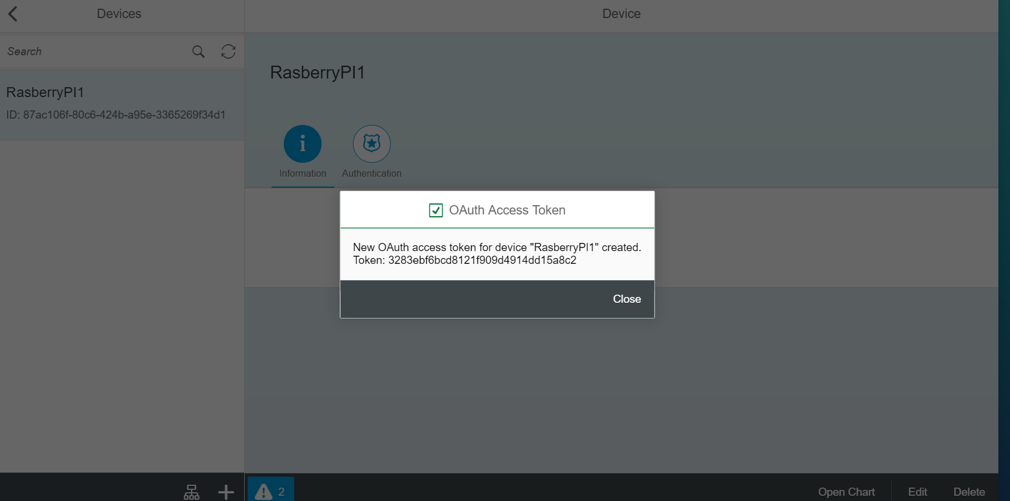

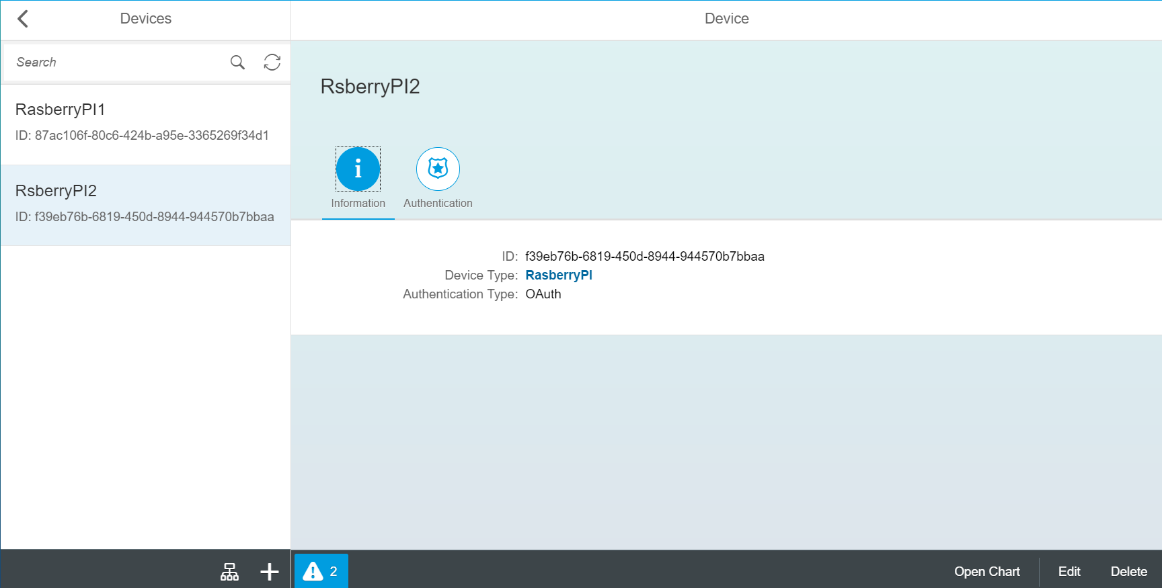

1. Now back to IoT Service Cockpit and click on “Redeploy the Message Management Service” link.

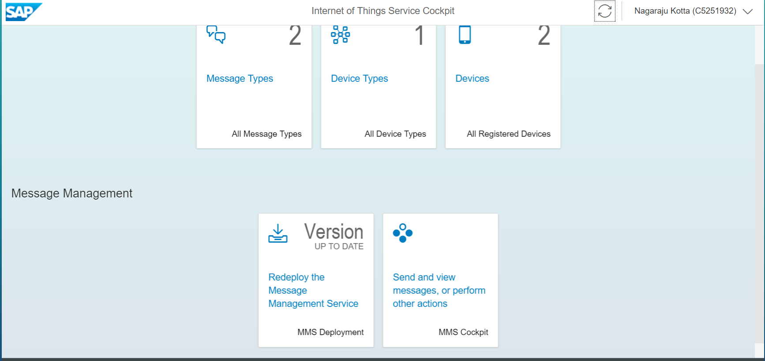

1. Enter the password and click on “Deploy” button. And popup window will open with message then click on “Deploy” button on popup window.

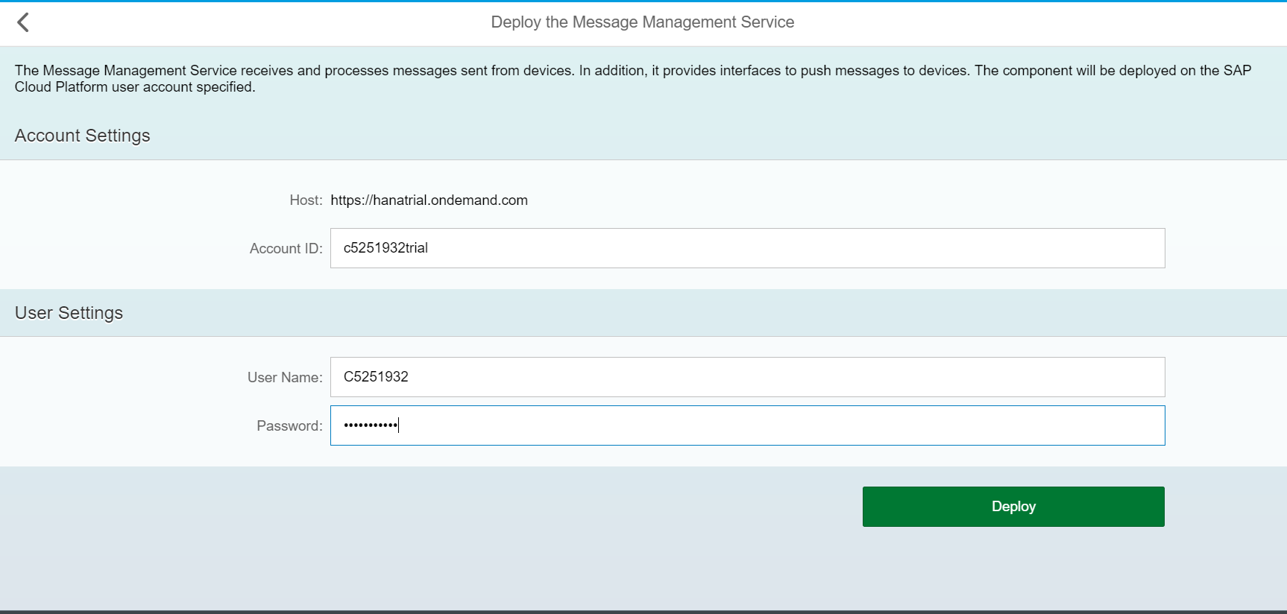

1. Now go back to the IoT service cockpit and click on “Send and view messages, or perform other actions” link. It will open in new window.

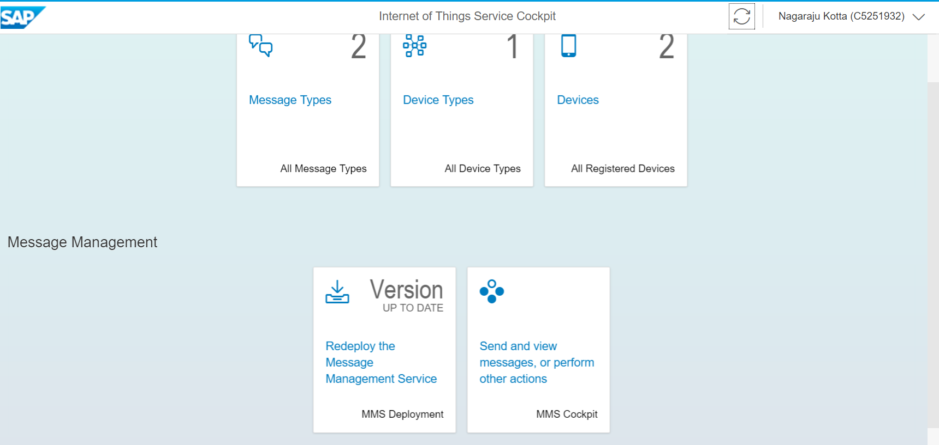

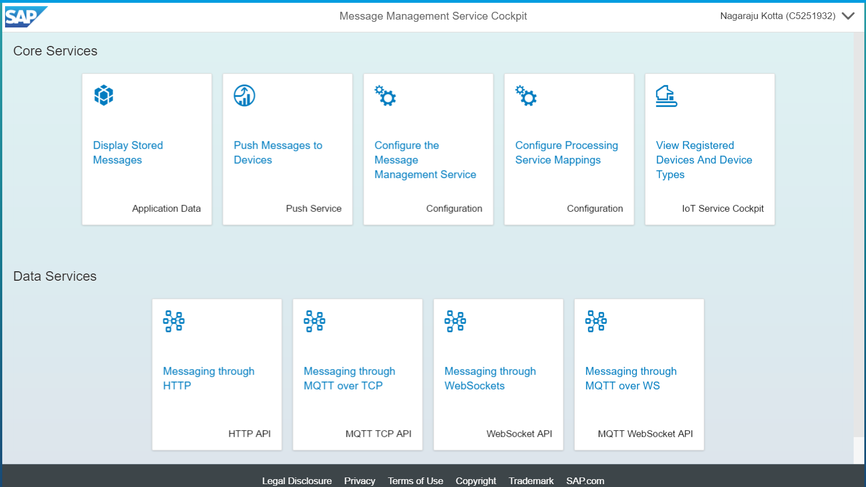

1. Click on “Display Stored Messages”, it will show the default tables

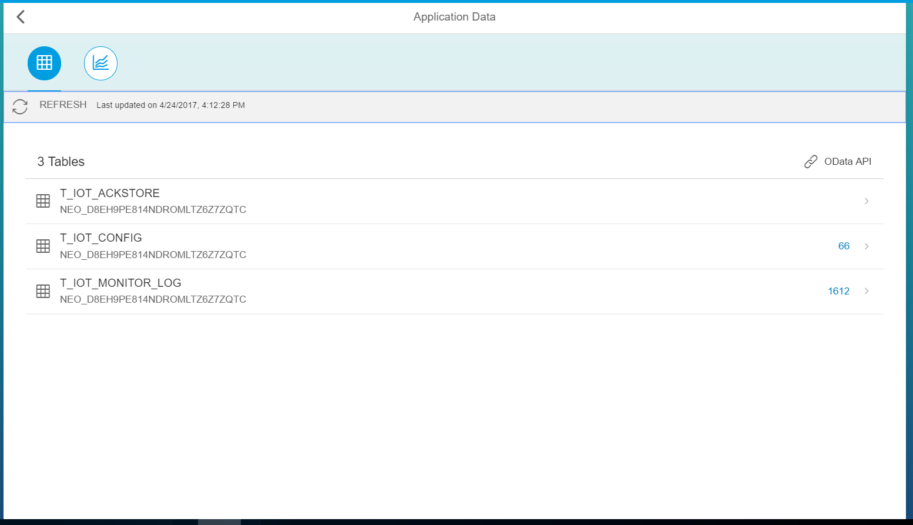

1. Go back to the “Message Management Service Cockpit” page and click on “Push Messages to Devices” link.

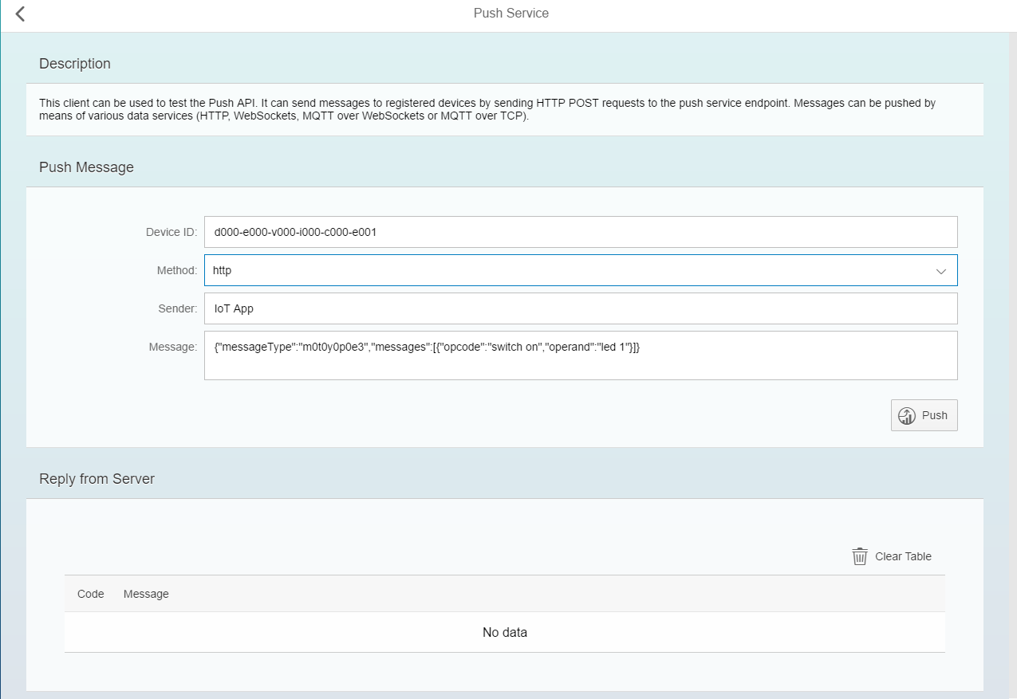

1. Go back to the MMS Cockpit page and click on “Messaging through HTTP ”.

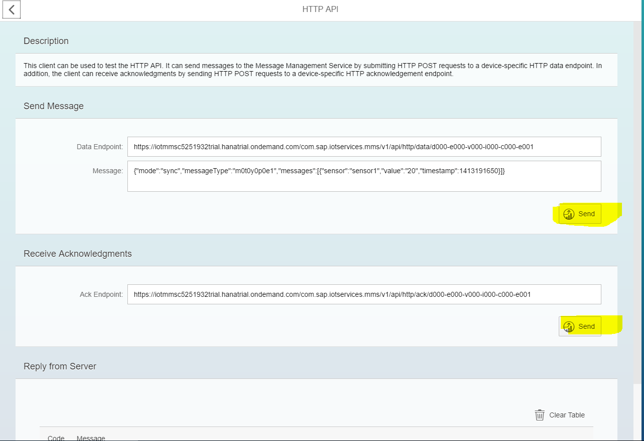

1. Click on “send” button from “Send Message” section, then you can able to see a message in “Reply from Server” section. That means the message has been successfully posted/sended.
2. Change the “Message” under “Send Message” section and click on “send” button”.

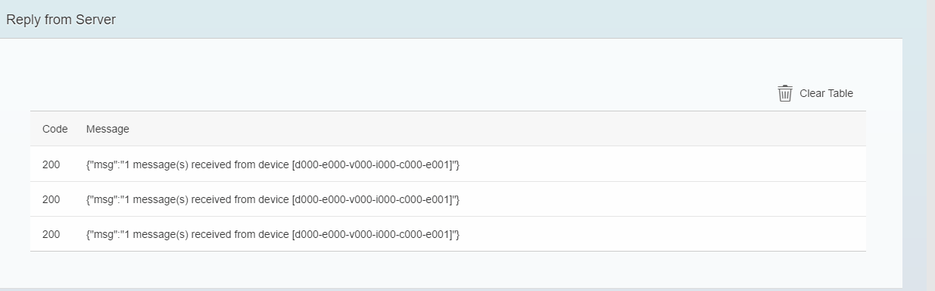

1. Go back to the “MMS Cockpit” and click on “Display Stored Messages” , now you can able to notice that, a new table is created.

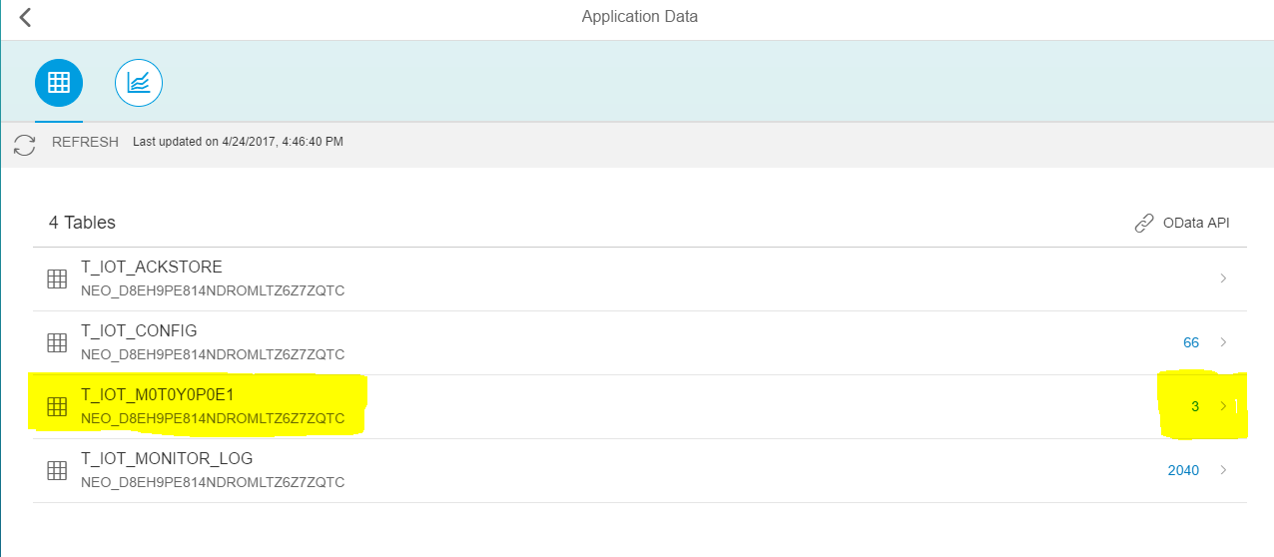

1. Click on link corresponding to the table ODataAPI section for more information.

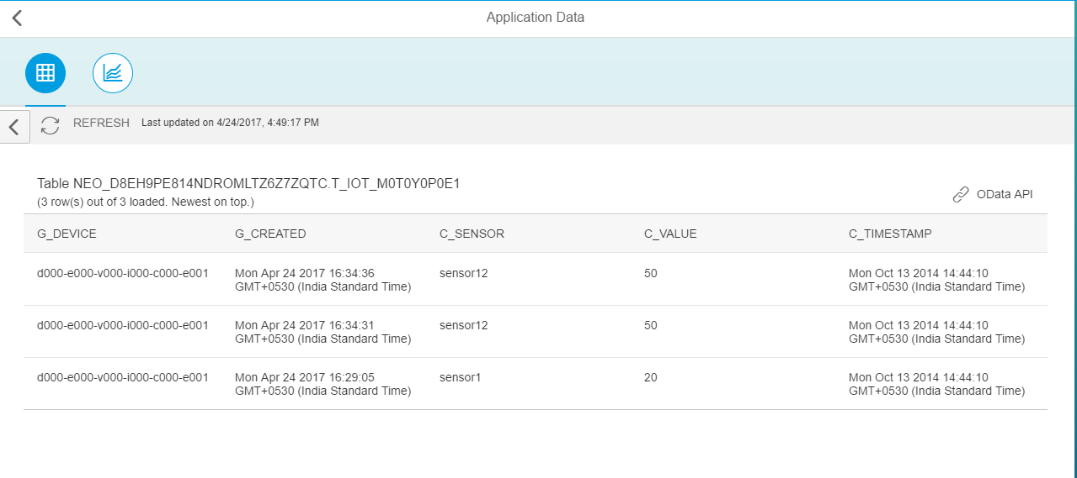

1. Now go back to the “MMS Cockpit” page and click on “Messaging through HTTP” link.
2. Change the device id.

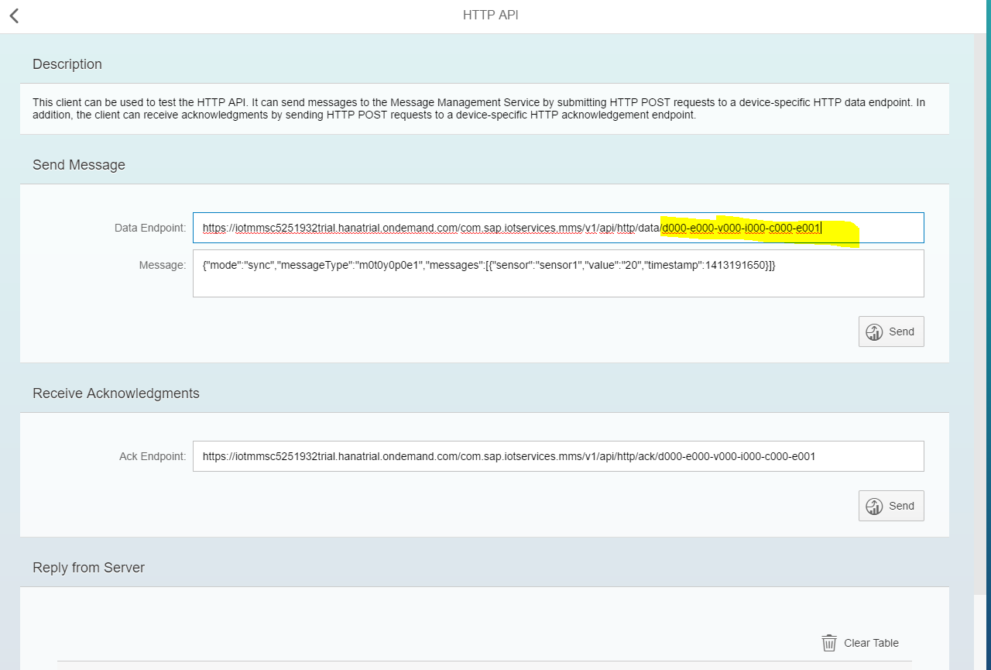

1. For changing the device id, you have to go to the “IoT service cockpit” page then click on “Devices” link, then click on any device(RasberryPI1), copy the “ID” and replace it in “Data Endpoint” of “Send Message” section. As shown in step 30(MMS Cockpit page).

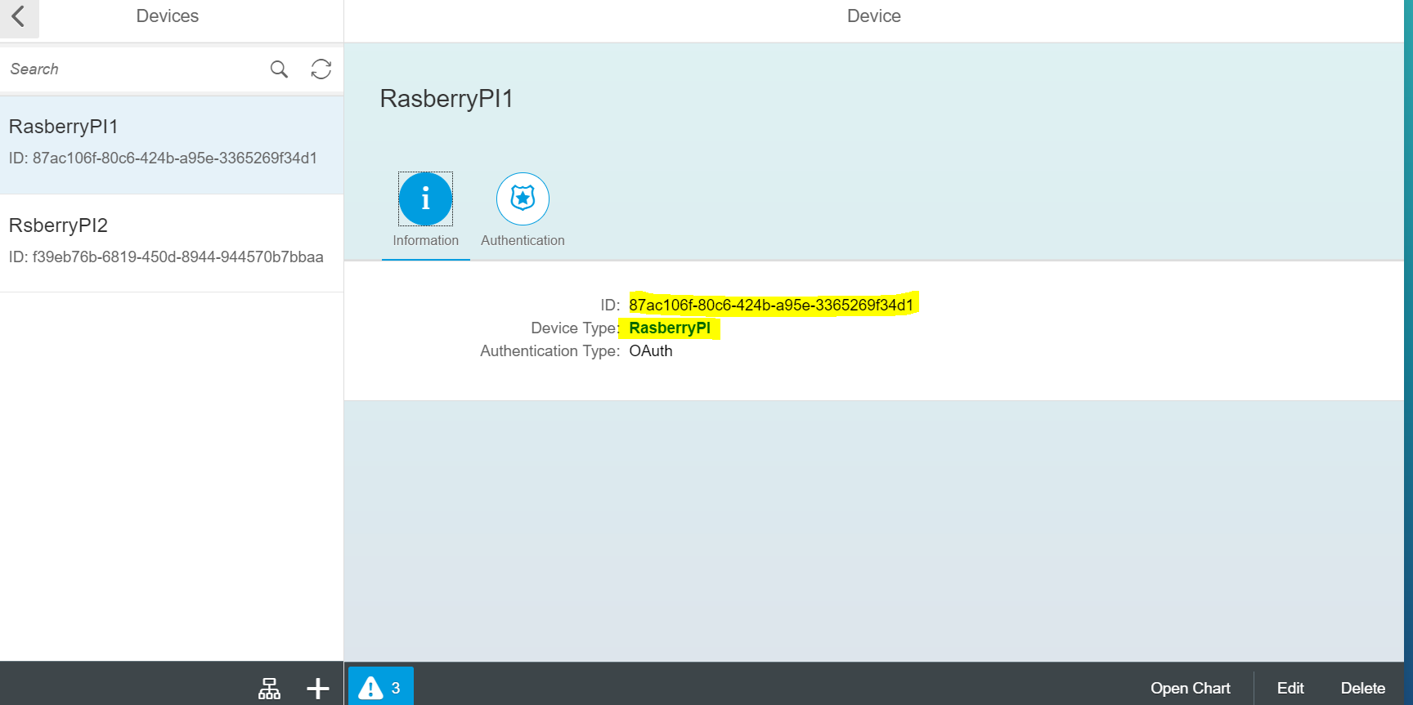

1. For changing ‘messageType’ , click on DeviceType url (ResberryPI) link. Click on “Msg.Types” option.

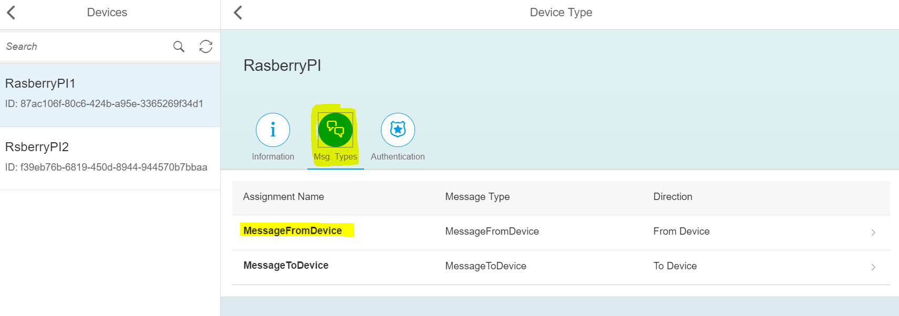

1. Click on “MessageFromDevice” copy the ‘ID’ and paste in “messageType” under “Send Message” option.

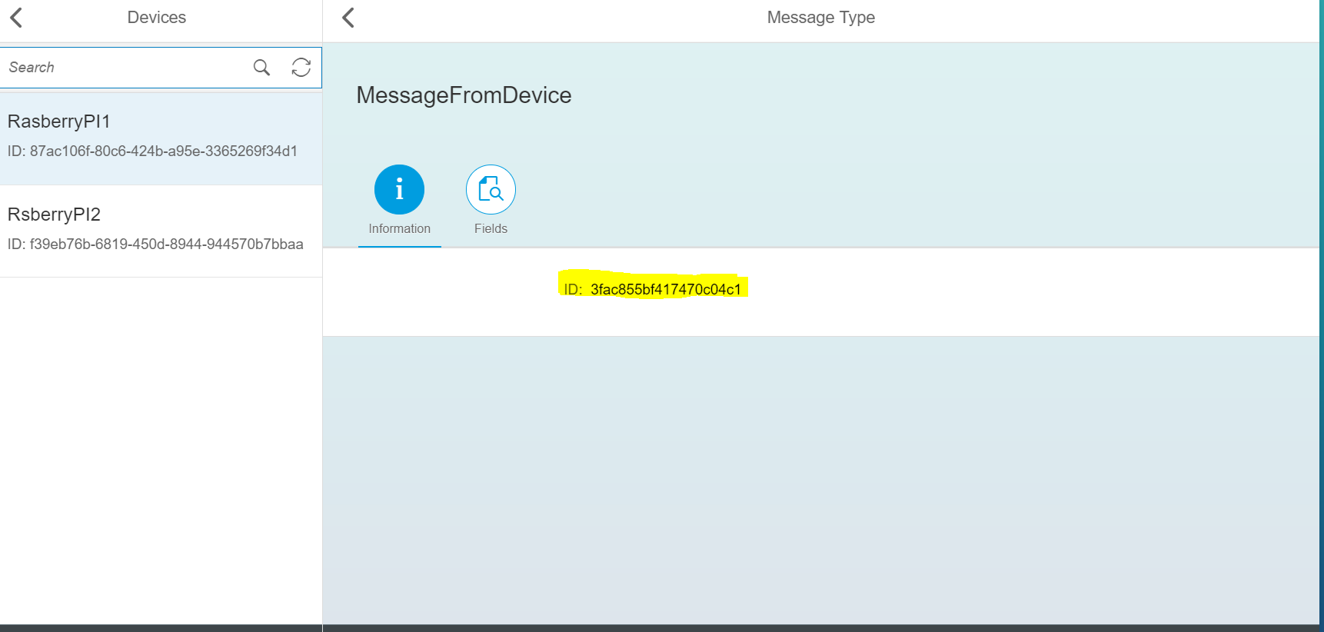

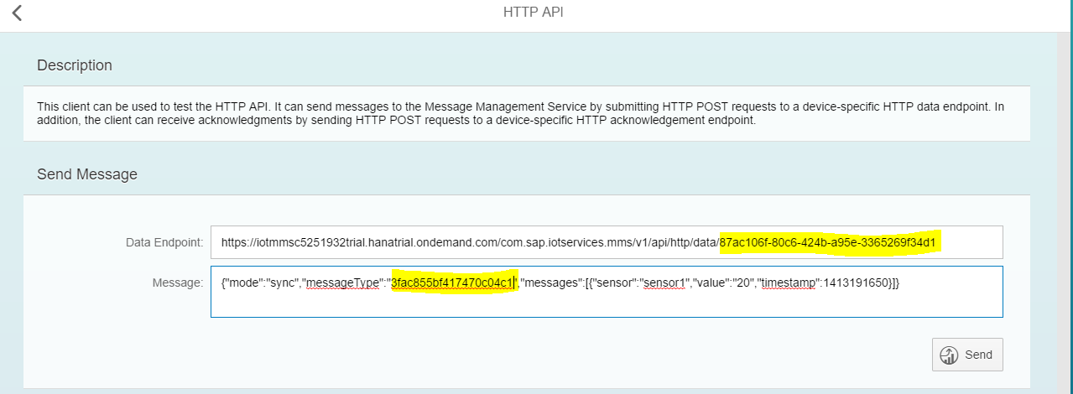

1. Change the sensor1,sensor2, and timestamp value(what ever the fields were added in MMS)

For getting timestamp value use the link <http://www.timestampgenerator.com/> , copy and paste ‘ISO8601’ value. And click on “send” button.

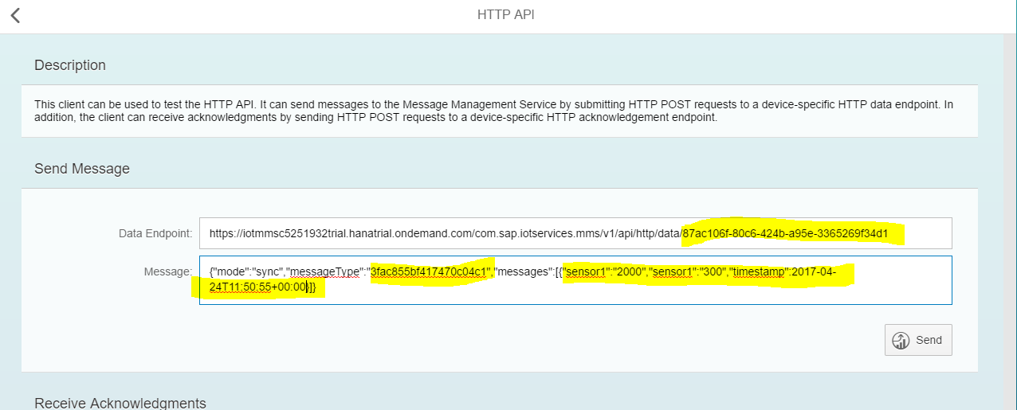

1. If the authentication failed then you would be get an authorized exception.

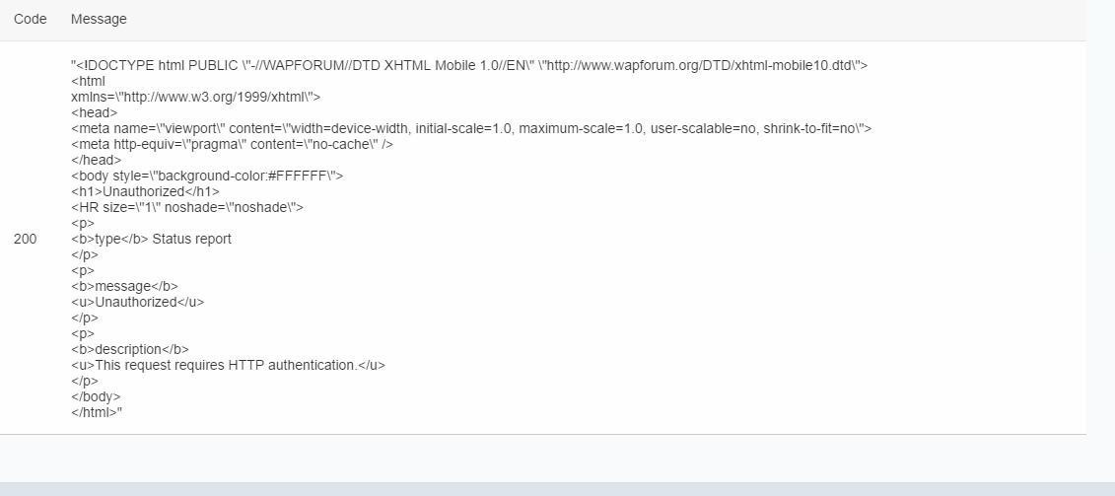

1. If authentication success, then you would get “ code 200” in “Reply from Server” section.

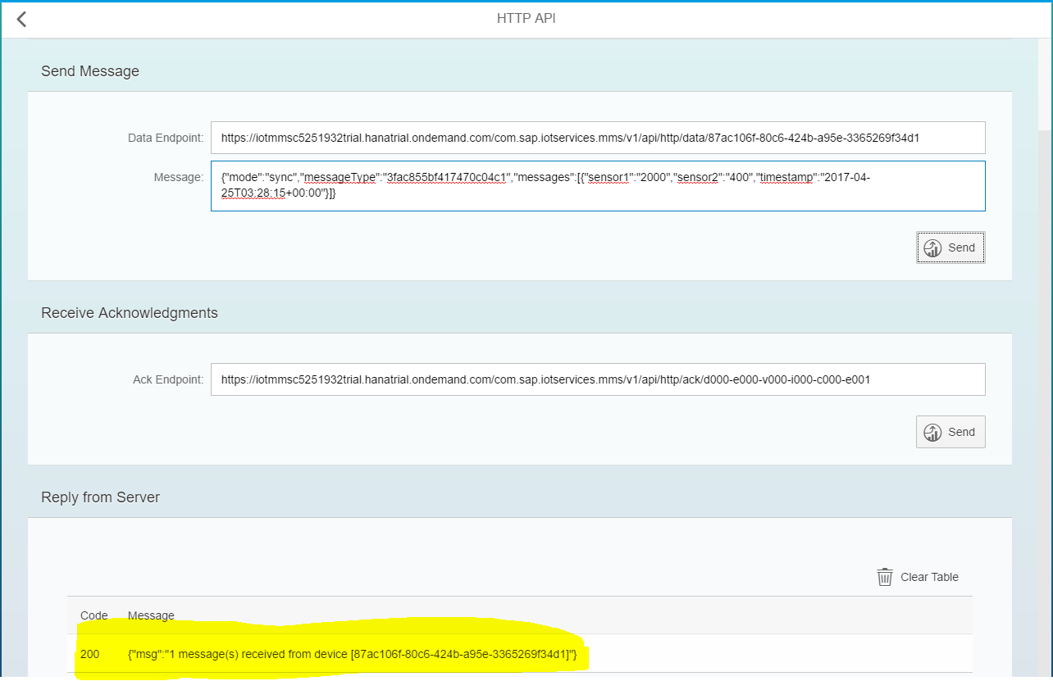

1. Go back to “MMS Cockpit” page and click on “Display Stored Messages” link, the you would navigate to corresponding window, there you would see a new table generated for the above “Send Message”.

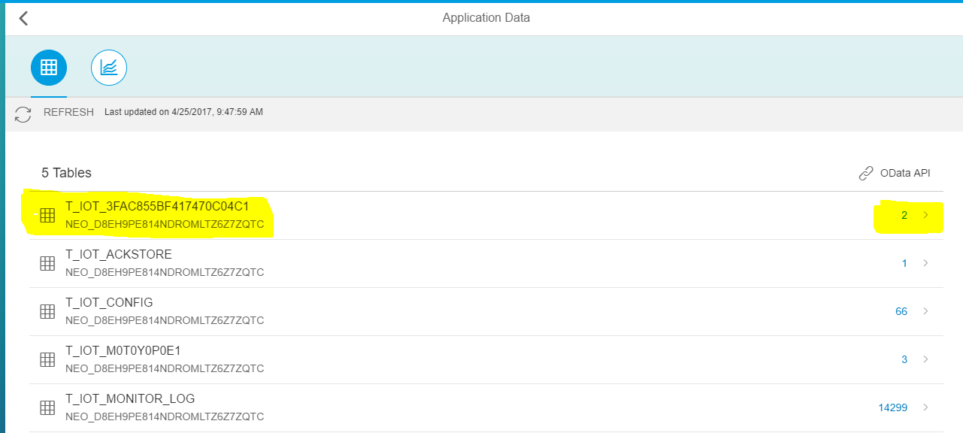

If you click on link under ‘OData API’ as shown in above screen shot, you would get the page like below screen shot.

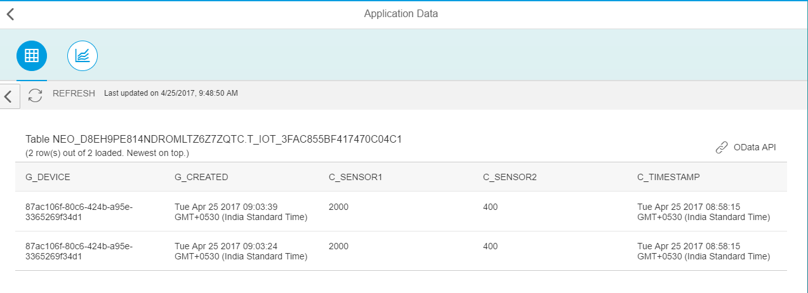

**Get the OData API URL**

1. Go to the ‘MMS Cockpit’ page
2. Click on ‘Display Stored Messages’

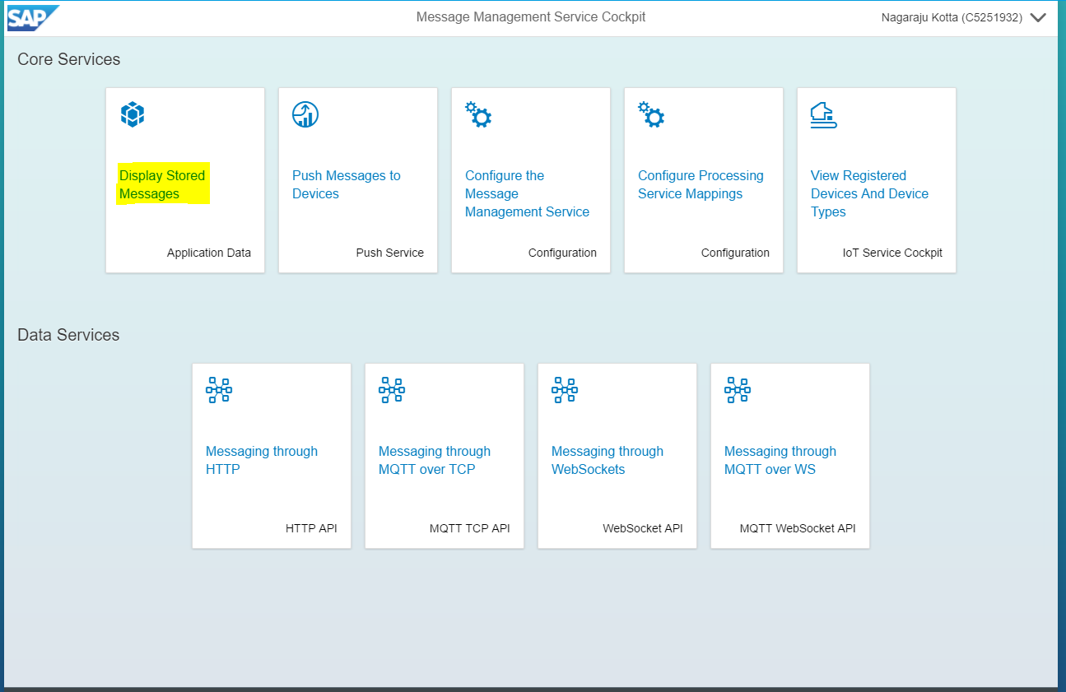

1. Click on ‘OData API’ link

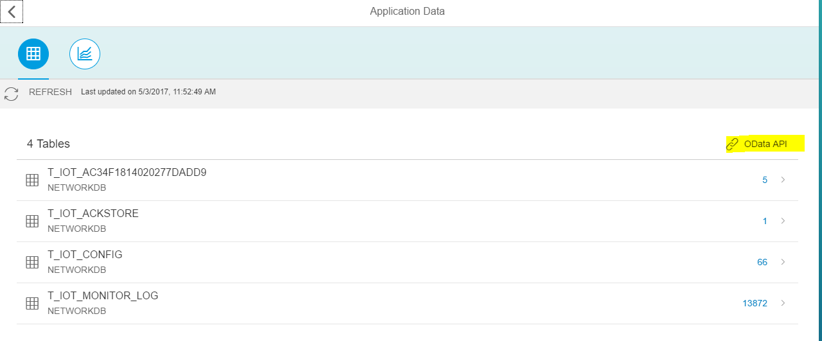

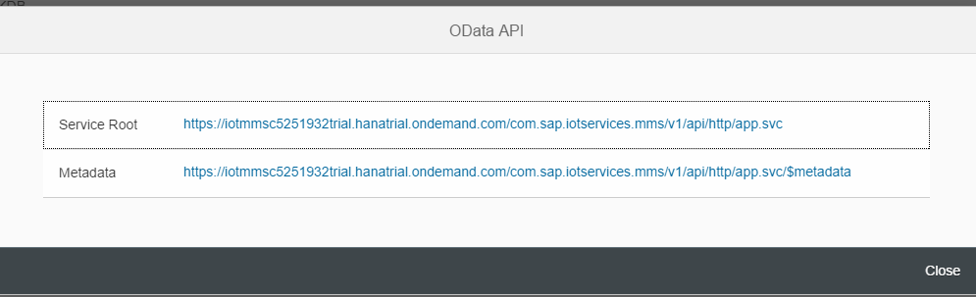

1. Copy the url (Service Root/Metadata) and paste in web browser

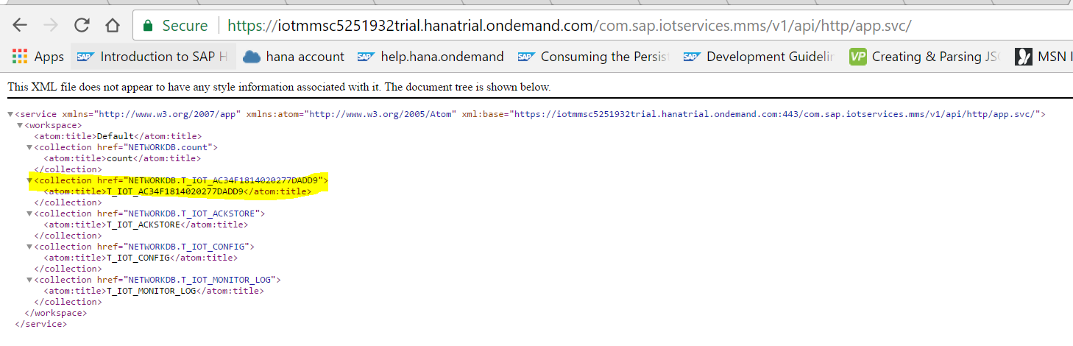

1. Select the required ‘colletion’ and paste after the url in browser

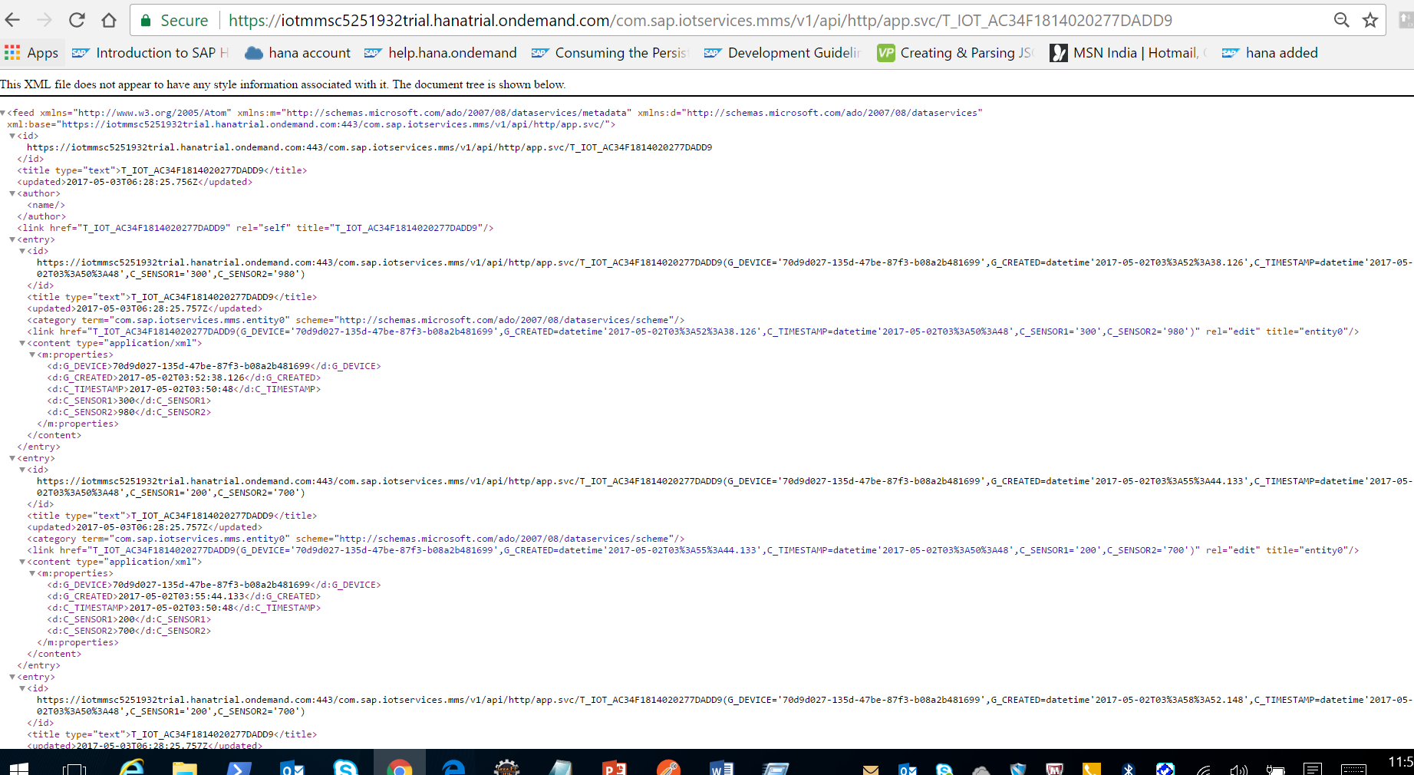

1. Now create a UI5 application to explore the data by using OData Service url.

**Configuring of Custom Schema/Database**

1. Configuring “Database & Schema”
2. Click on “Databases & Schemas” under “Persistence” tab of HCP Cockpit. You can find the default schema created for iot mms application.
3. Delete the default ‘Data Source Bindings’.

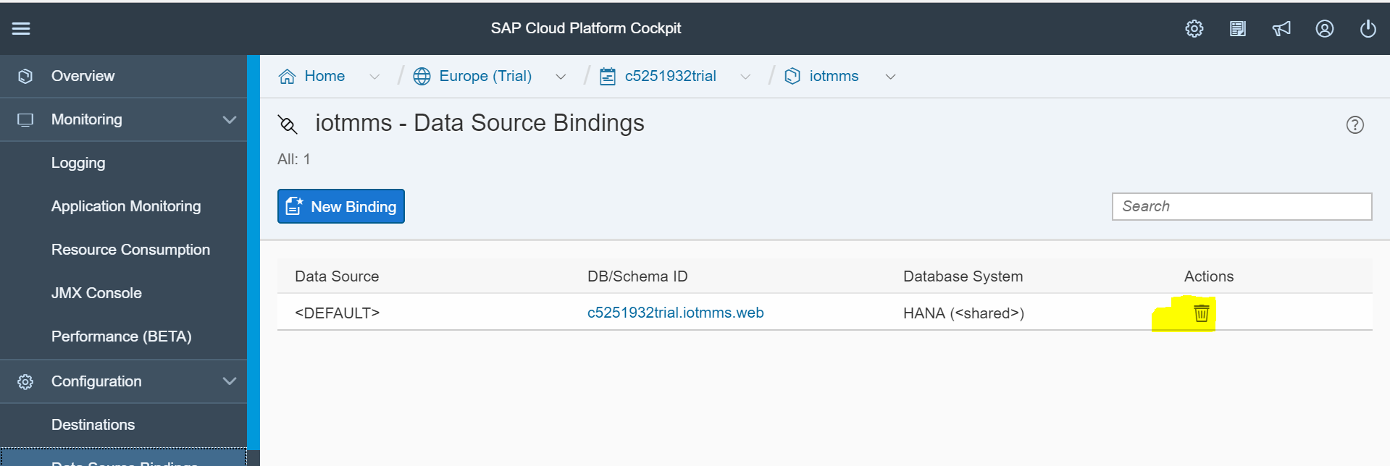

1. Click on ‘New Binding’, select DB/Schema ID from dropdown -> provice Database User and Password and click on ‘Save’ button.

Note :- leave ‘Data Source’ field as ‘<default>’

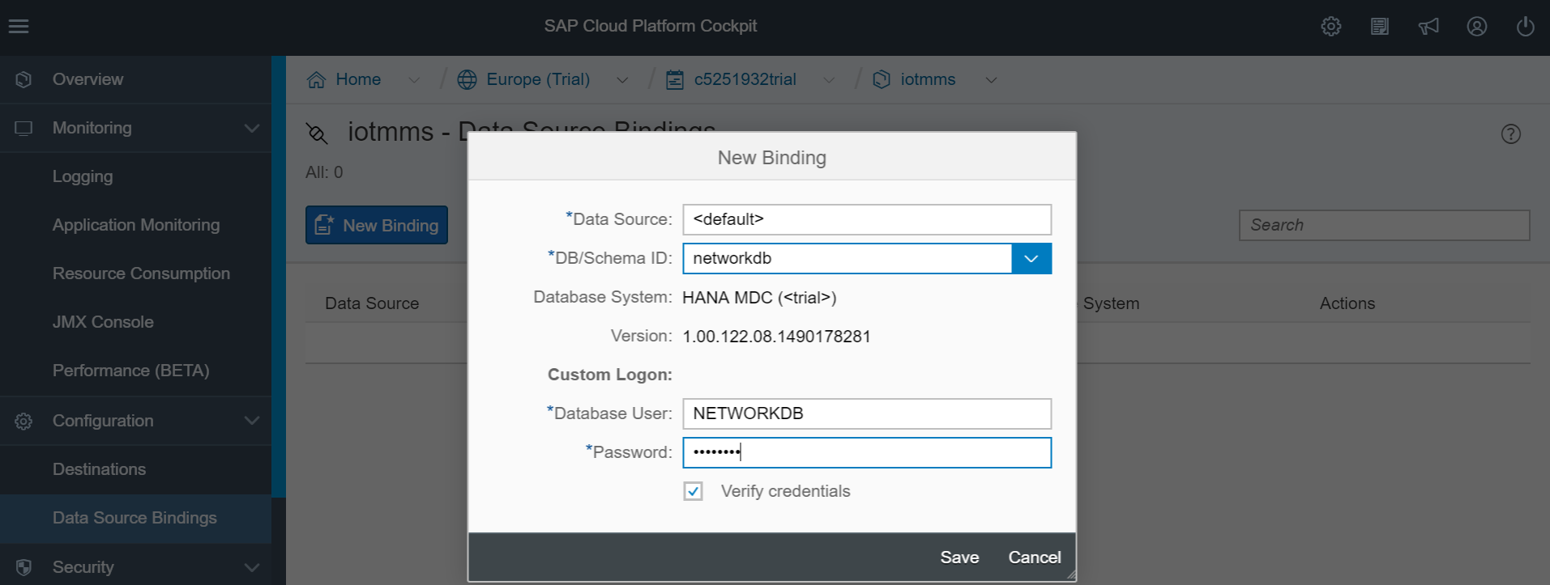

1. Go to Persistence -> Databases & Schemas -> select default iotmms schema -> click on ‘Delete’ button.
2. Now Go to ‘IoT Service Cockpit’ -> click on ‘Redeploy the Message Management Service’ -> click on ‘Deploy’ button.

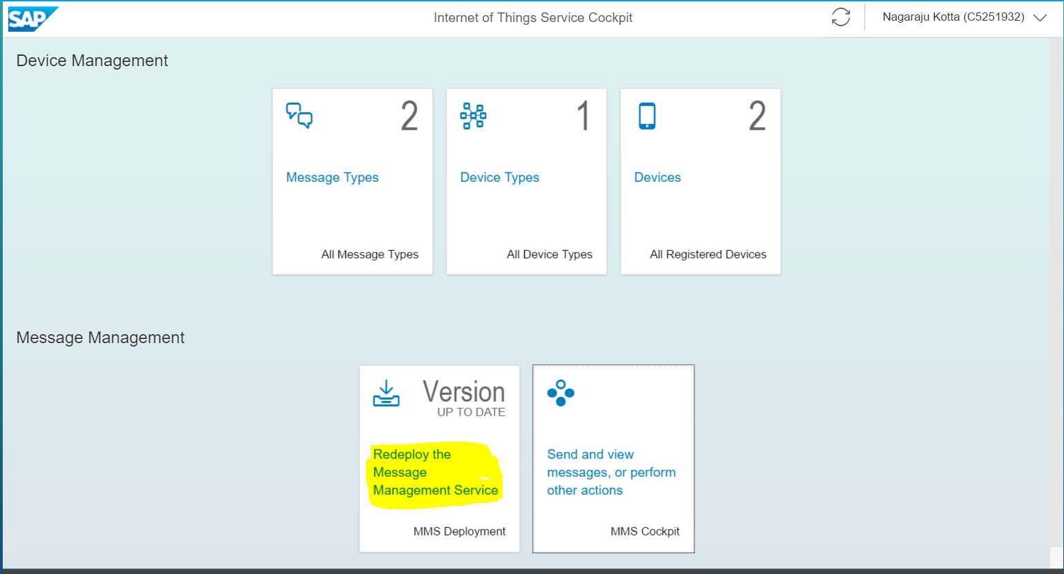

1. Go to ‘IoT Service cockpit’ -> click on ‘Send and view messages, or perform other actions’

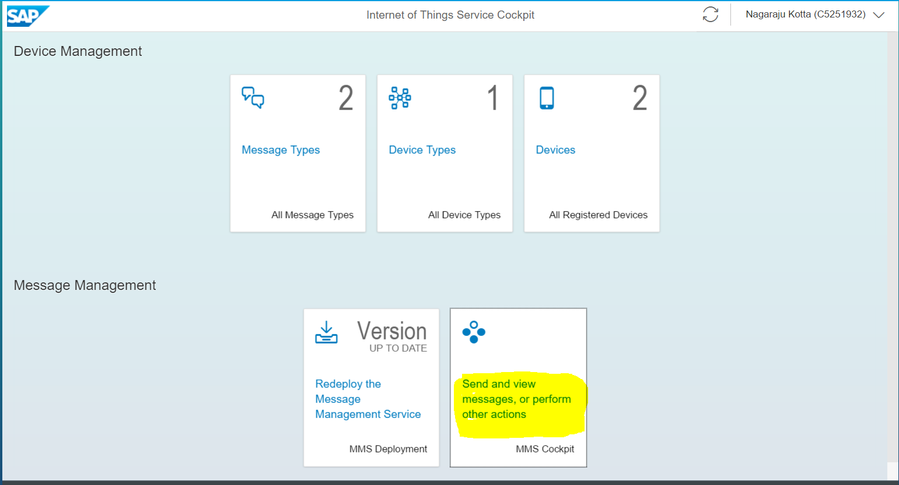

1. Click on ‘Configure the Message Management Service’

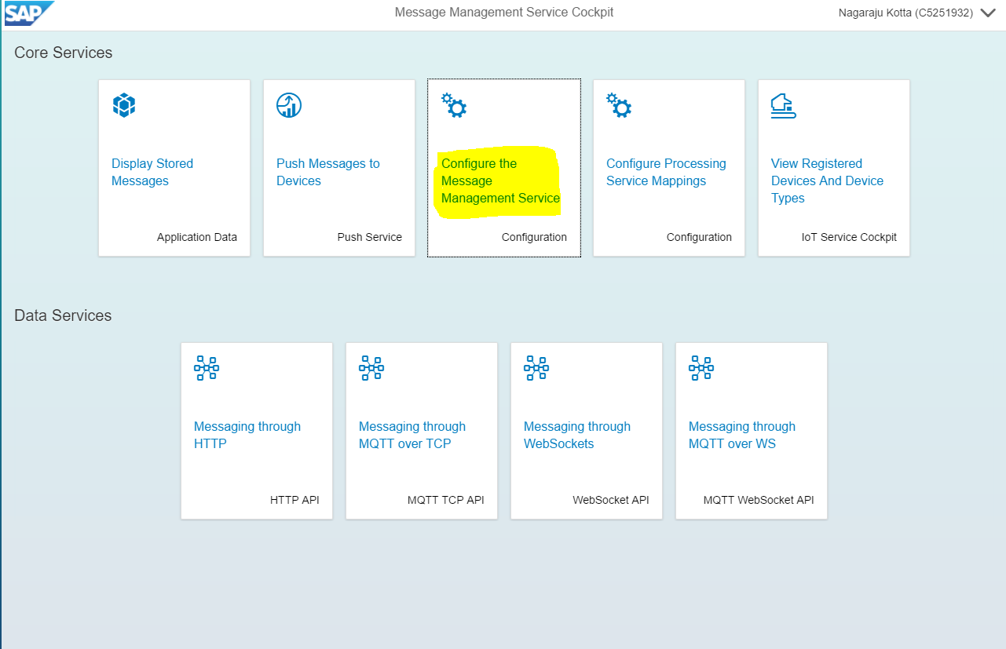

1. Now you can see the changed Database Schema name.

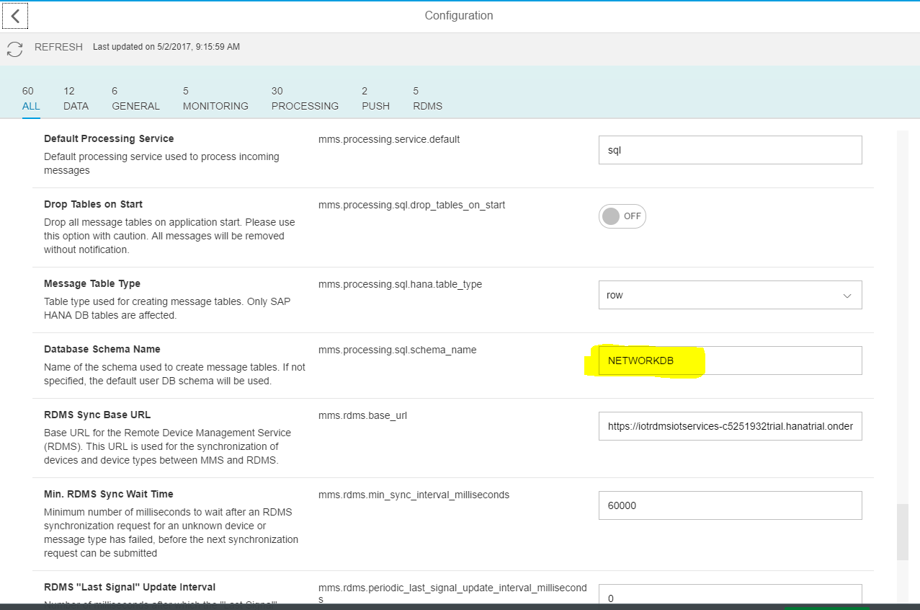

1. Go to ‘MMS Cockpit’ page -> Messaging through HTTP

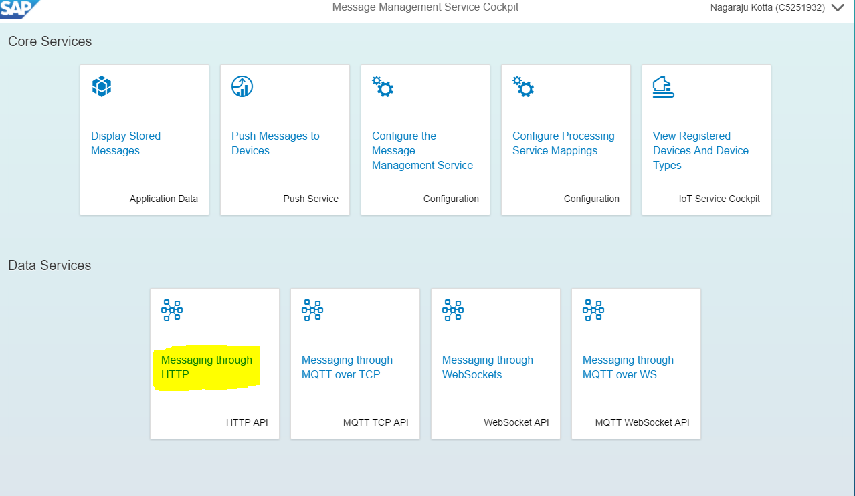

1. Provide DataEndpoint and Message then click on ‘Send’ button.

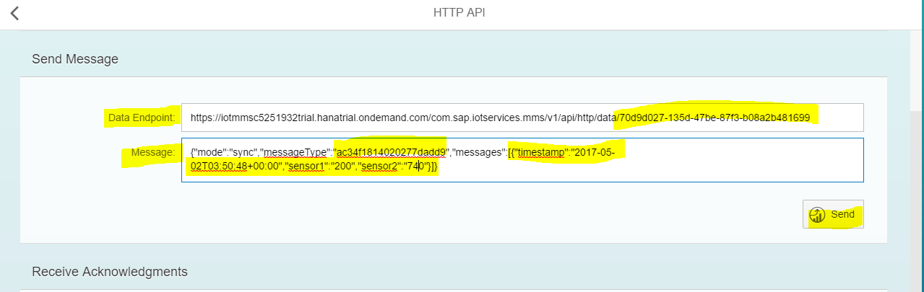

1. Now you can see the default tables created under the custom database/schema.

Note : default table will be created with messageTypeId ex:

T_IOT_AC34F1814020277DADD9.

Creating a Customized Database Table for IoT Application

1. Go to ‘MMS Cockpit’ page, click on ‘Configure Processing Service mappings’

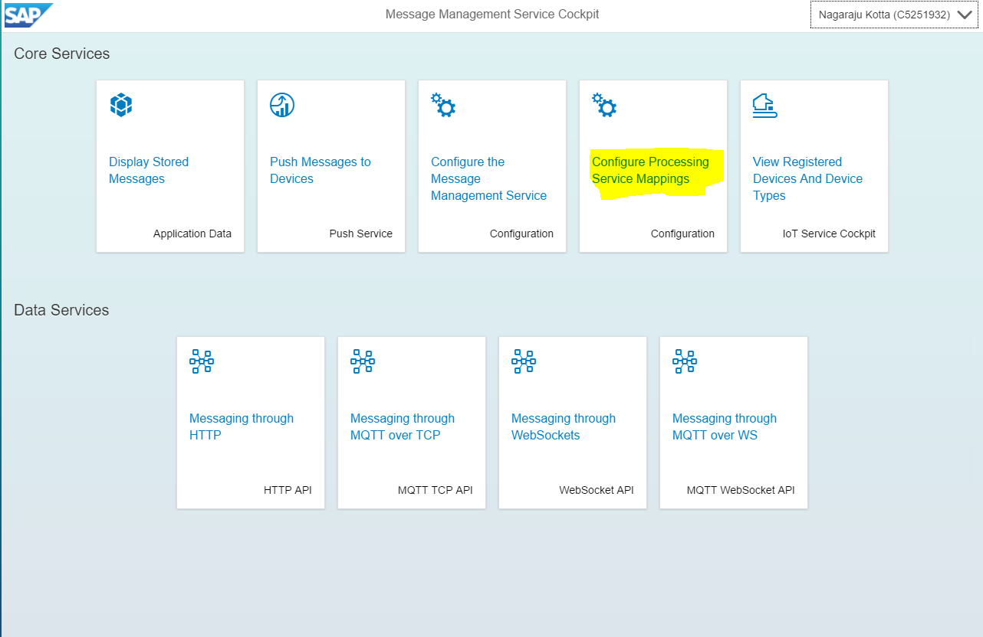

1. Click on ‘ + Add Mapping’

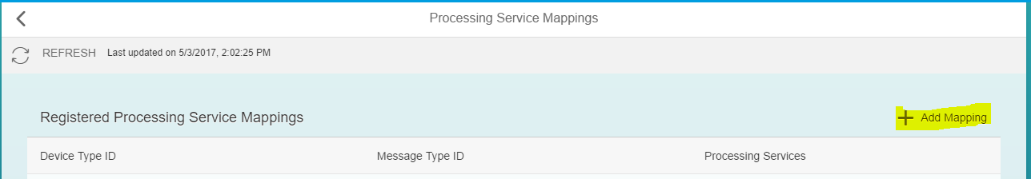

1. Provide ‘Device Type ID’ and ‘Message Type ID’, get the DeviceType and MessageType ID’s from ‘IoT Cockpit’ Page.

Click on ‘Device Types’

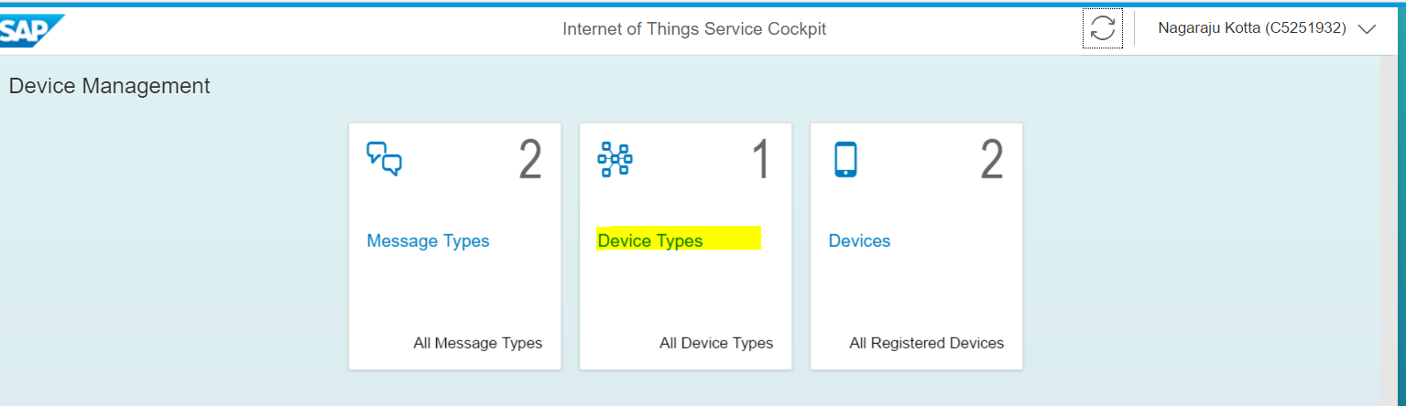

1. Copy ‘ID’ and paste in ‘Device Type ID’ and click on ‘Msg.Types’ button.

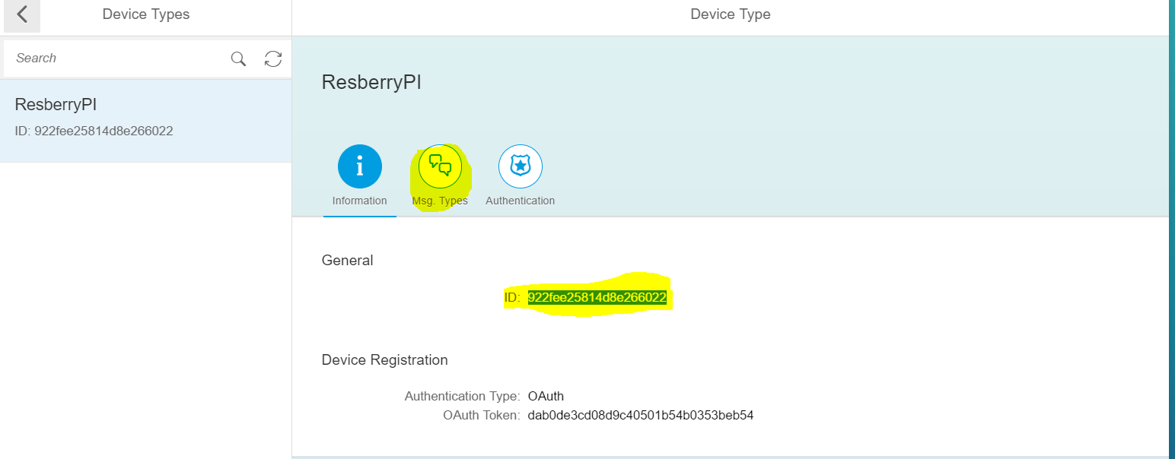

1. Now select ‘ MessageFromDevice’

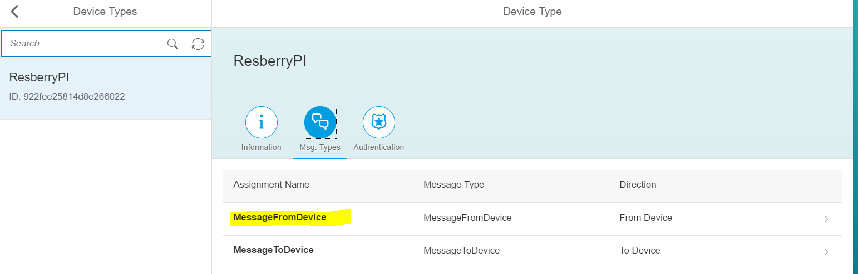

1. Copy message id and paste in ‘MessageTypeID’

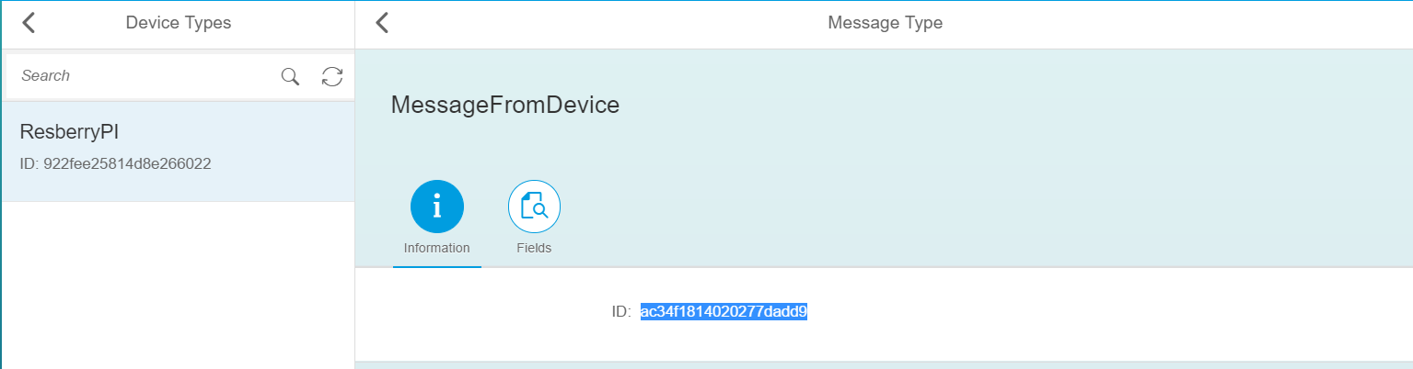

1. Click on ‘+ Add Processing Service’ button.

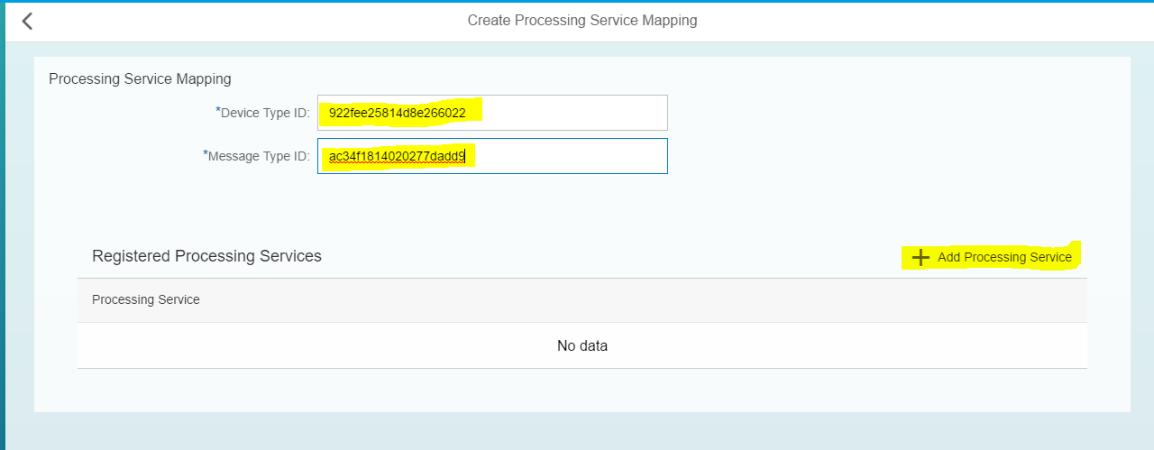

1. Click on ‘sql’

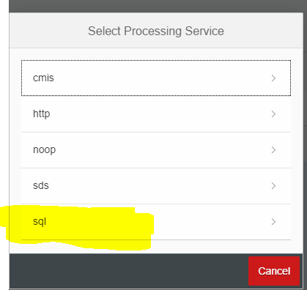

1. Enable all the fields then provide table_name , click on ‘+Add Column Mapping’ link to add custom column names to the new table.

as shown in screenshot. Then click on ‘Back to Message Map’

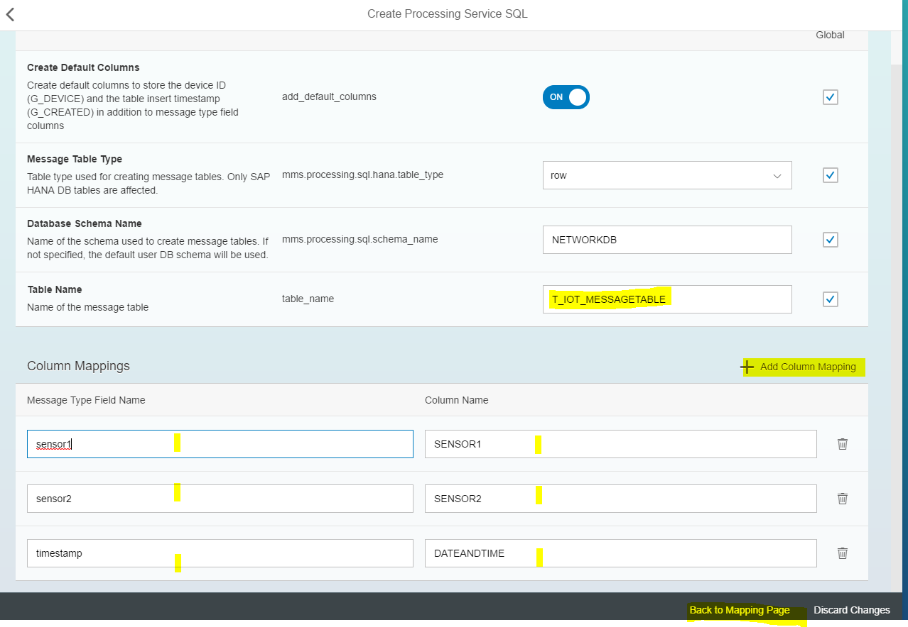

1. Click on ‘Create’ Button.
2. Now click on ‘Messaging Through HTTP’ in ‘MMS Cockpit’ page
3. Give inputs to ‘Data Endpoint’ and ‘Message’ then Click on ‘Send’ button.

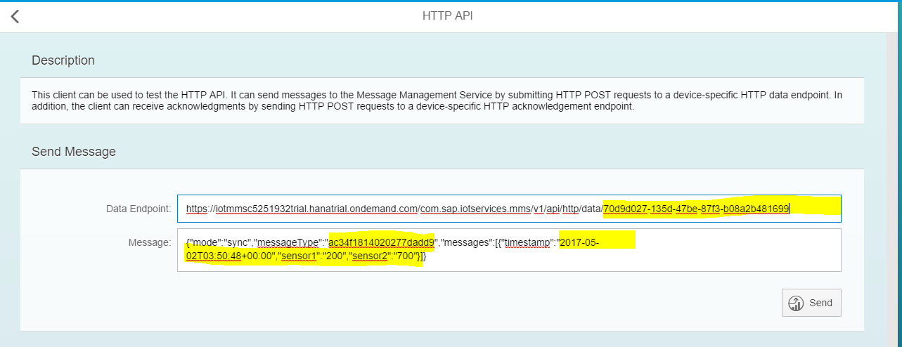

1. Now click on ‘Display Stored Messages’ in ‘MMS Cockpit’ page, now you can see the table created.

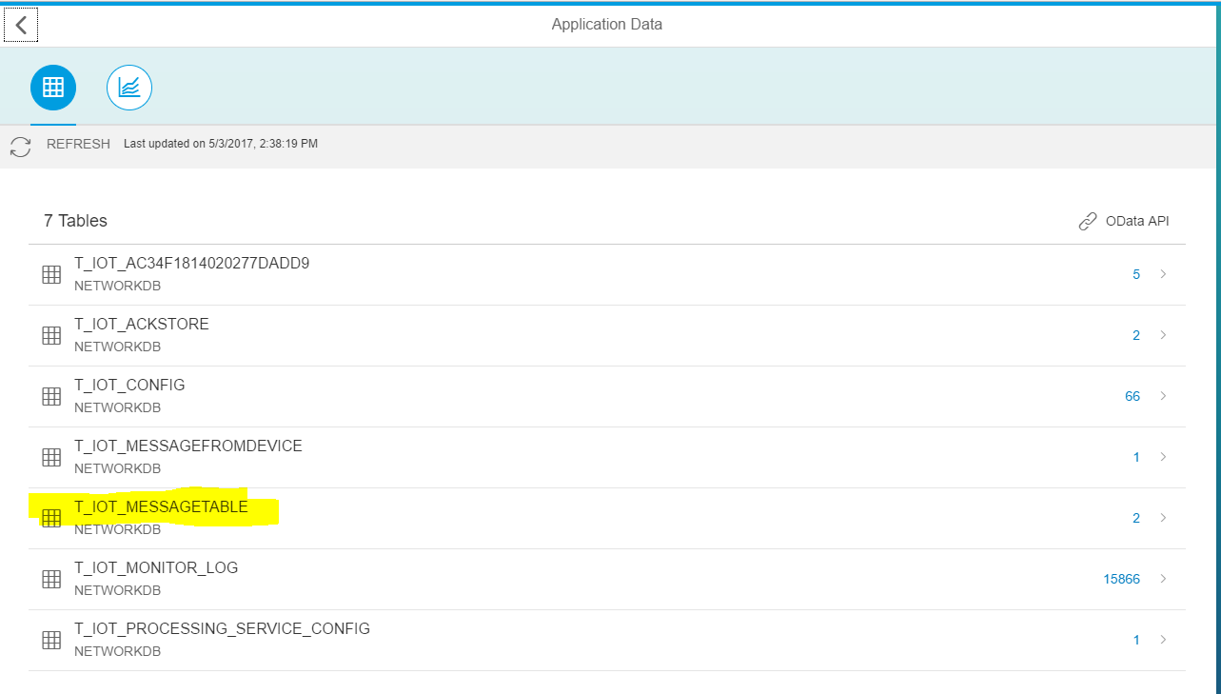

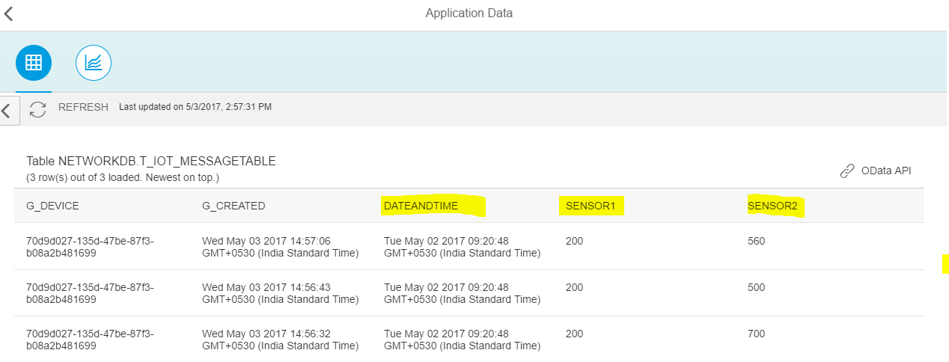

Eclipse view:

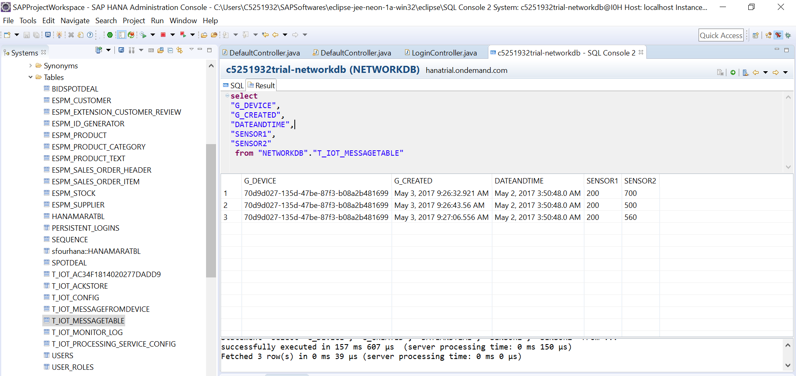

Note : If you configured the database/schema in Eclipse, then you can able to see the created tables under your schema/database tables.

Note : Once you created a custom table in MMS cockpit, then you cannot alter it through MMS cockpit. You can altering through Database.

**Configuring Destination in HCP Cockpit for creating OData Service in ‘WEB IDE’ – SAPUI5 Application.**

1. Go to the HCP Cockpit -> Connectivity -> Destinations.

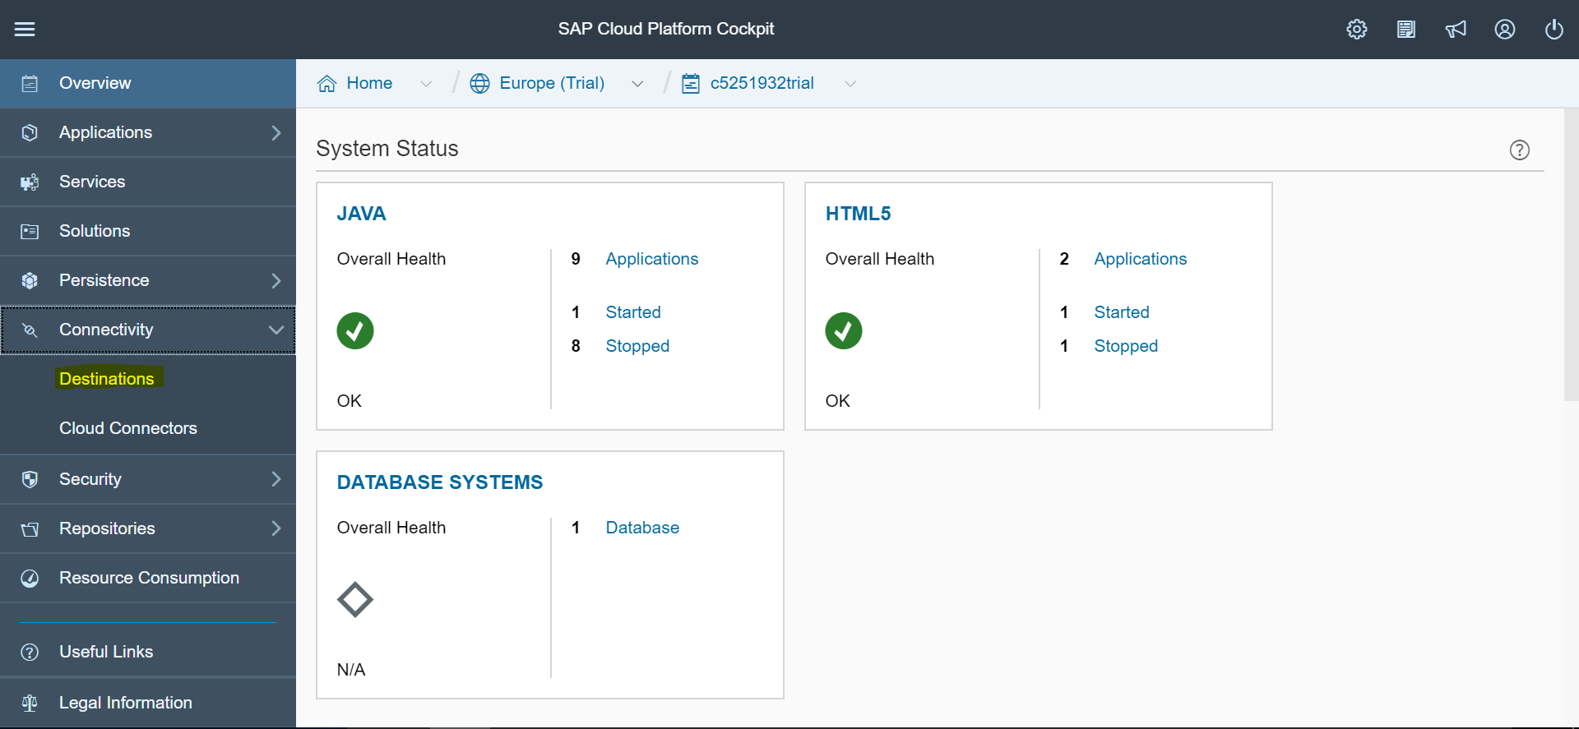

1. Click on ‘New Destination’

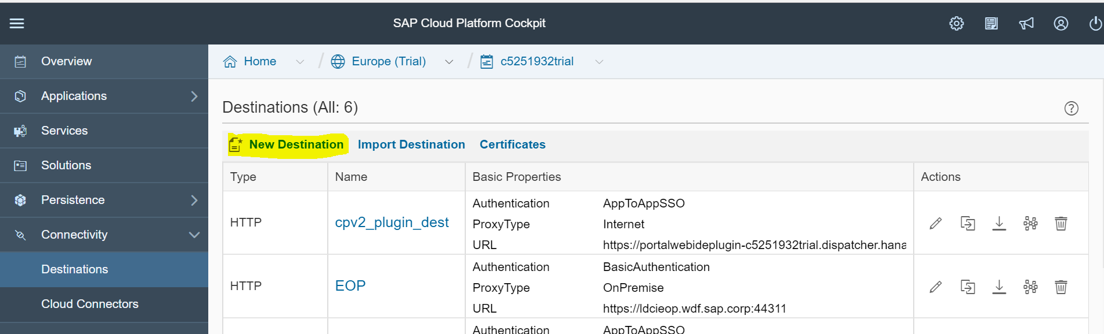

1. Provide the required information.

URL :- copy the OData API url from ‘MMS Cockpit’ page.

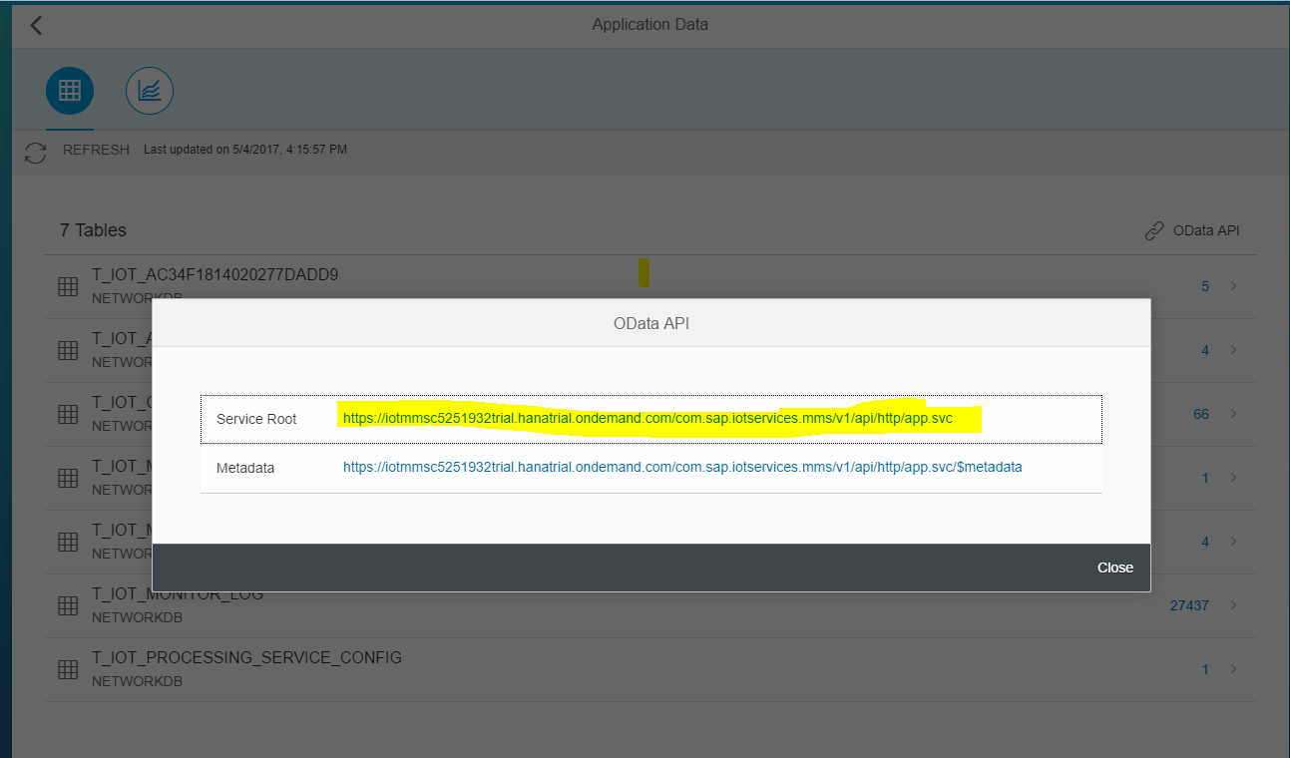

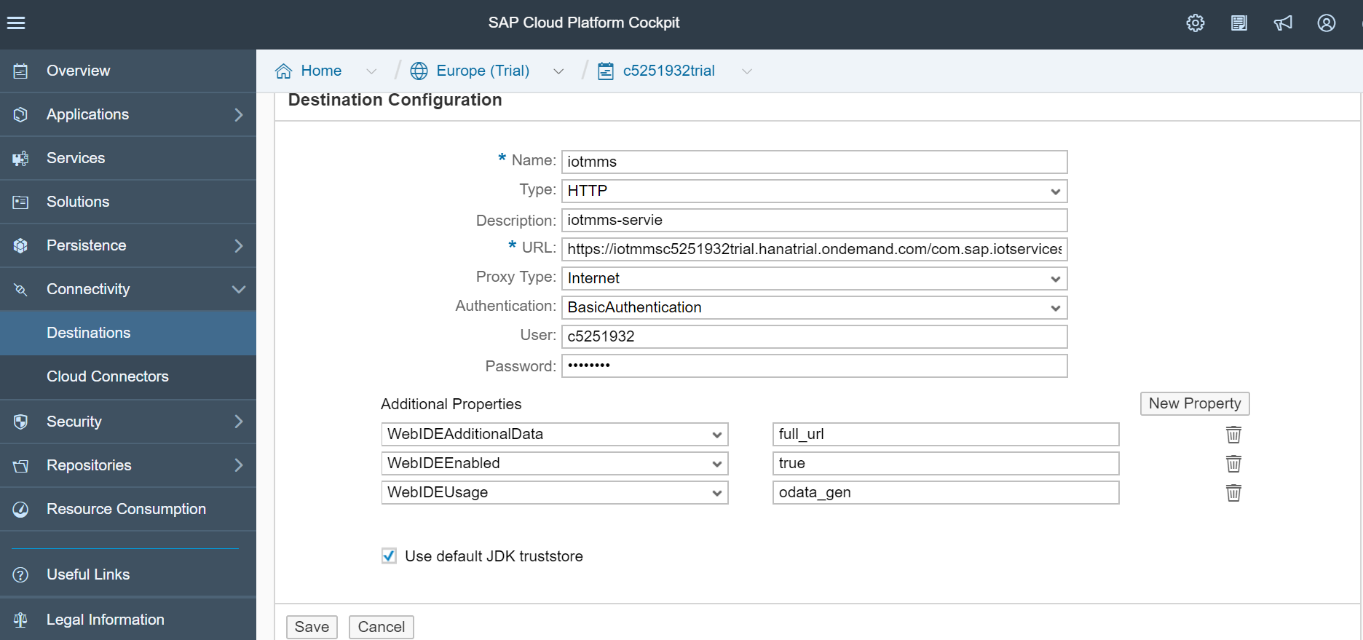

**Creating a SAPUI5 Application – Fetching Data from IoT tables by using OData Service and explore in ui5 app.**